AME532a Final Report

04/21/2020

Jiaoran Wang

6205909903

Contents

AME532a Final Report 0

**Abstract** 2

Chapter 1: Introduction 3

Chapter 2: ASW28 Flight Control System 4

2.1 State Equations 4

2.2 Control System Design 4

2.2.1 Overall System Design 4

2.2.2 Aero Surface Controller Design 5

2.2.3 Propeller Design 5

2.3 Controller Design 6

2.3.1 Autopilot Controller Concepts 6

2.3.2 PID controller design 6

*Supplement 8

Chapter 3: Model Trim and Linearization 9

3.1 Model Trim 9

3.1.1 Model Trim (without aero surface) 9

3.1.2 Model Trim (with aero surface) 10

3.2 Model Linearization and Steady-state Flight 11

3.3 Linear States Analysis 11

3.3.1 Aircraft Dynamic Stability Analysis 11

3.3.2 Lateral/Longitudinal Motion Control 12

3.3.2 Linear Controller Design 17

3.3.3 LQR for Full Linearized System 19

3.4 Discrete Linearized System 19

3.4.1 System discretization in Simulink 19

Chapter 4: ASW28 Flight Dynamic Analysis 21

4.1 Introduction 21

4.2 XFLR5 Dynamic Analysis 21

4.2.1 Model Design 21

4.2.2 Dynamic Coefficient Calculation 21

4.3. ANSYS Dynamic Analysis 22

4.3.1 Finite Element Analysis 22

4.3.2 Aerodynamic Distribution 23

Chapter 5: Simulation 24

5.1 Simulink to FlightGear 24

5.2 Maneuver in Steady-state Flight 24

5.2.1 Pilot Control Simulation 24

5.2.2 Skid to Turn 25

5.2.3 Slipping Turn 28

Conclusions 29

References 30

Useful links 31

**Abstract**

The aerodynamic model of this report is based on the data of ASW28 model and 12 equations of steady state. The research objectives are the design of model control system and the basic aerodynamic analysis.

Firstly, the non-linear system block diagram is built as well as controllers applied using MATLAB & Simulink.

Secondly, PID controllors are designed for the both non-linearized and linear system for dynamic analysis and motion stability control.

Then,the dynamic analysis results from XFLR5 and ANSYS FLUENT are compaired to enhence the comprehension of flight dynamics and also optimize the dynamatic coefficients in control systems.

Finally, the block diagrams connect with FlightGear for the controller simulation display. Flying maneuvers such as ‘Skid to turn’ is realized through linearized system.

Chapter 1: Introduction

The ASW28, as a Standard Class glider with a fifteen-meter span built of modern fiber reinforced composites, has sailplane with a T-shaped horizontal tail plane and 15-meter wingspan. The upper wing surface has Schempp-Hirth brake flaps.

This report uses ASW28 model data for base model calculation:

Figure 1-1. ASW28 Data Chart

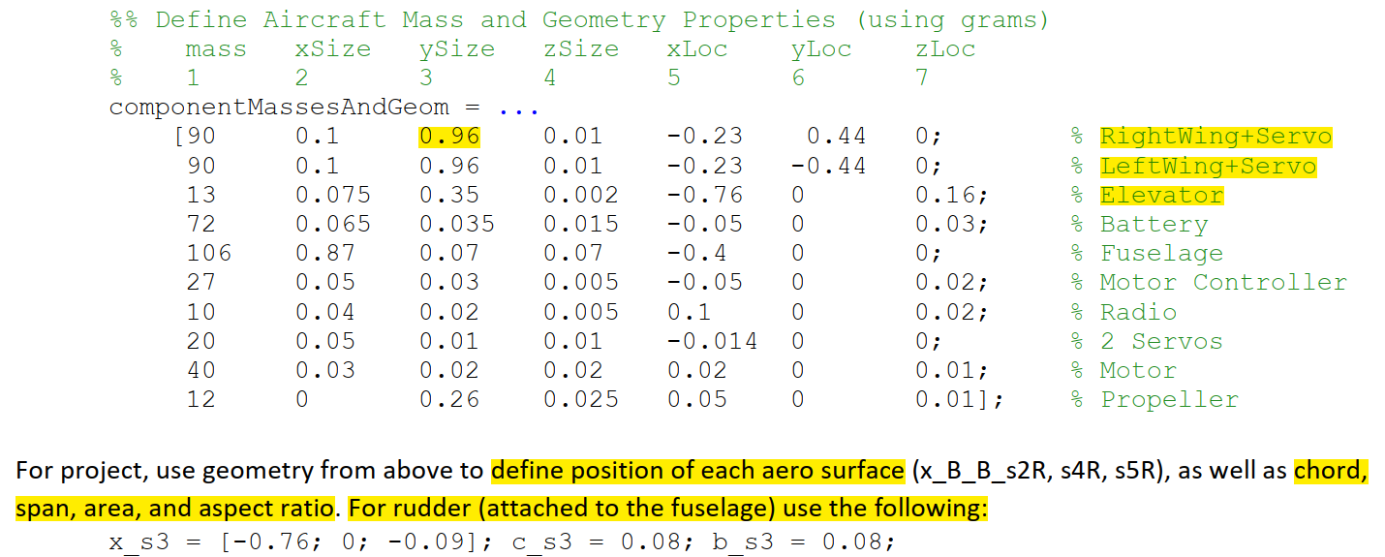

This report focuses more on the controller design for the system block diagram than the conditions which may alter the flight stability, however, the flight/environment conditions, propulsion system influences on inertia and mass change may also be coverd as well.

Chapter 2: ASW28 Flight Control System

2.1 State Equations

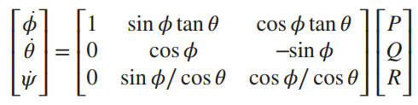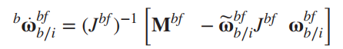

Figure 2-1. Control System State Equations

**(2-1)**

**(2-2)**

**(2-3)**

**(2-4)**

The above figure shows the 12 state-equations which are the base of control system, which is also the basic theory for block diagrams[1]

2.2 Control System Design

2.2.1 Overall System Design

The dynamic control system contains five sub systems: Translational Kinematics & Dynamics, Rotational Kinematics & Dynamics and Aero Surface. Most of the imported parameters are calculated outside the Simulink blocks in order to reduce the number of systems calculating steps.

Figure 2-2. Control System

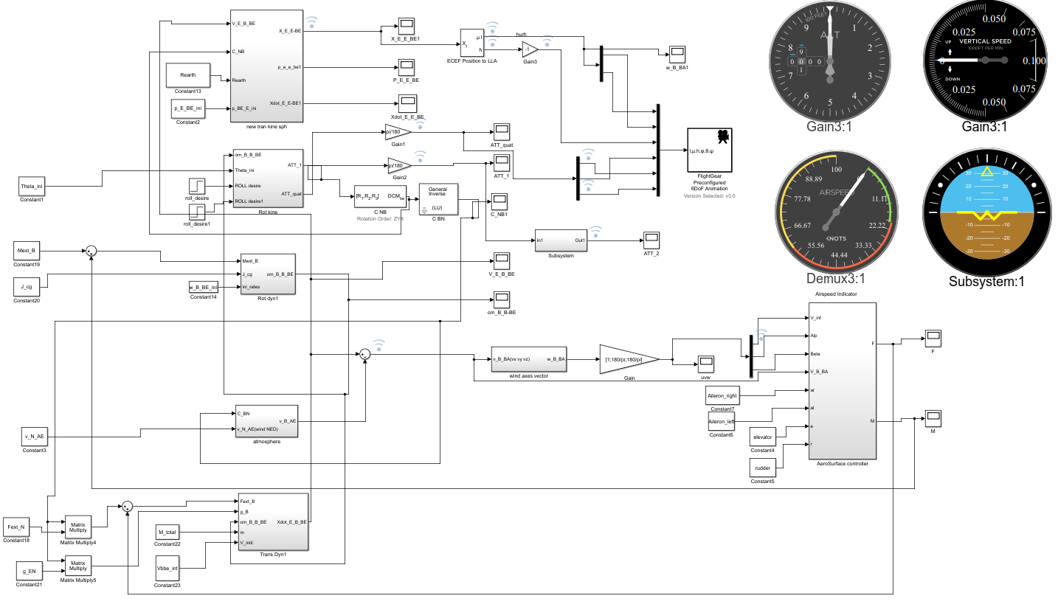

2.2.2 Aero Surface Controller Design

For the real-time force and moment calculation, the aero surface infections could be added to the CL_s according to the blocks. What should be noticed is the experimental parameters are all 0.5 regard to the item [aero surface area/ controlled surface area]

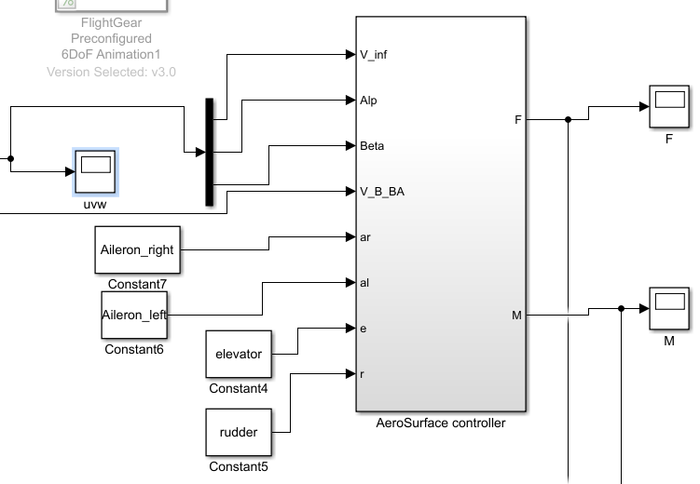

Figure 2-4 Aero Surface Block and Real-time Inner Force and Moment

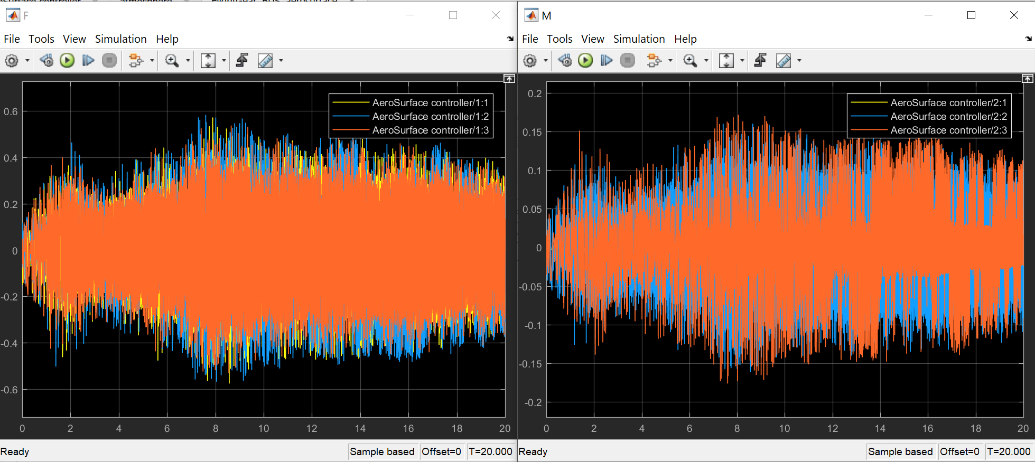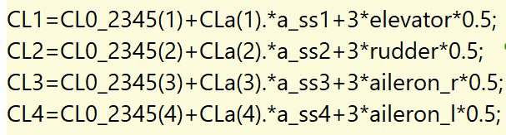

Figure 2-3 Full Span Control Surface coefficient

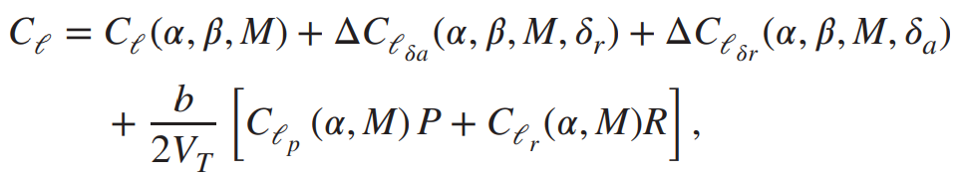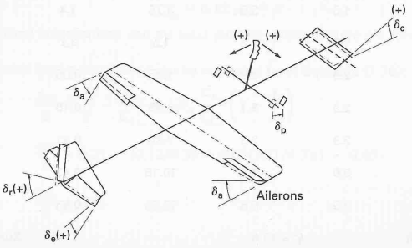

2.2.3 Propeller Design

Adding propeller with rotating set of angled blades could provide thrust[2] for an airplane, as the figure 2-5 shows. In this design, the propeller direction is set to be [0;0;1] which could provide redundant lift for ASW28 model.

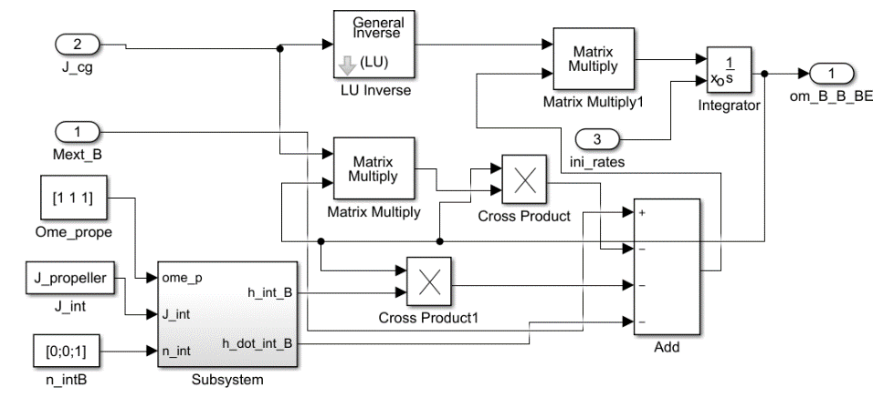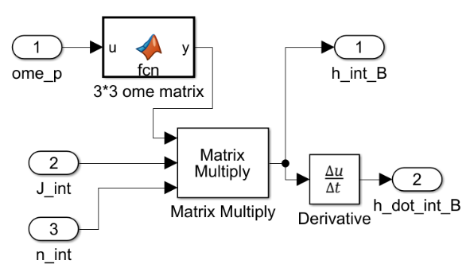

Figure 2-5. Propeller Block Design

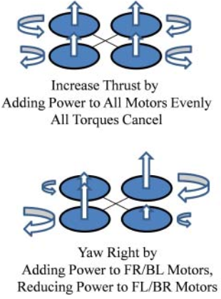

2.3 Controller Design

2.3.1 Autopilot Controller Concepts

The figure shows how autopilot control system works by using inner and outer feedback loop to control ailerons then reach desired roll positions. Following the same principle, we could design different controllers for elevator to control pitch and rudder for yaw angles, in which case, the aero control system is added into the system. Besides, the parameters (such as V_inf) should change in real time.

Figure 2-6. Autopilot Roll Angle Control Design

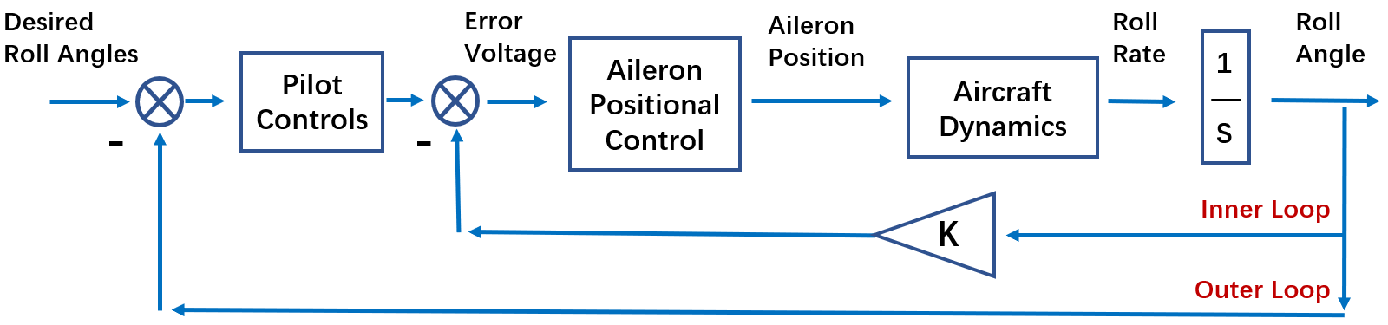

Rolling moments are created by sideslip alone[3], by the control action of the ailerons and the rudder, and as damping moments resisting rolling and yawing motion.

After applying the aero surface into the blocks, the inner force and moment will change in real time.

2.3.2 PID controller design

**1) PID in Rotational Kinemics loop**

Inside Rotational Dynamics, The PID controller is set up to eliminate the flight tremor during the cruising flight. Enlightened by autopilot block design in simulation, the PID controller is applied before Euler angle changed along the rotational rates in Body system respect to Earth reference frame. By using PID tuning system, the pitch and yaw offset curve vibration could be reduced.

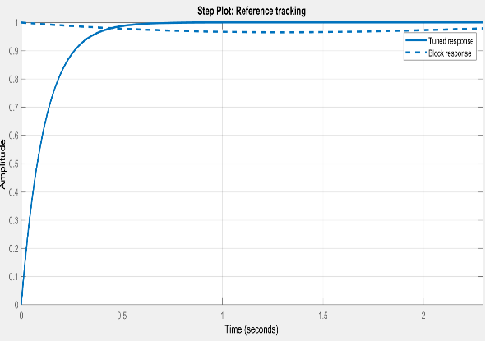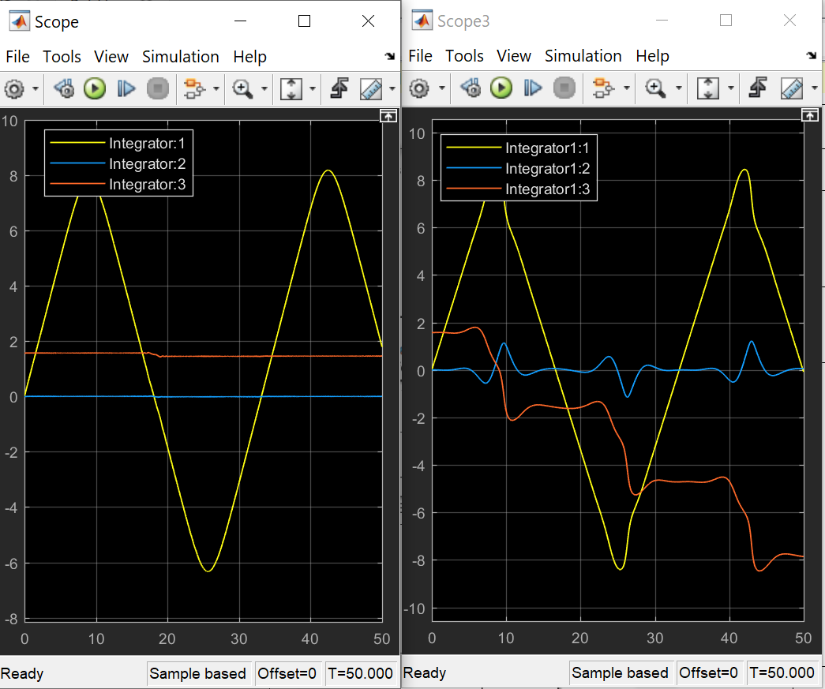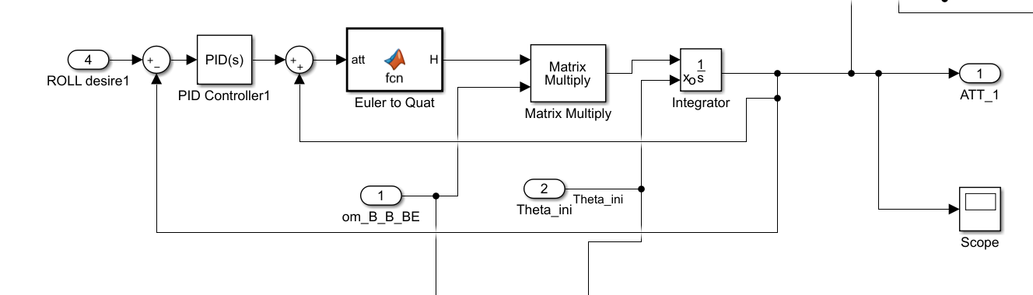

Figure 2-7. PID Controller Design for vibration elimination

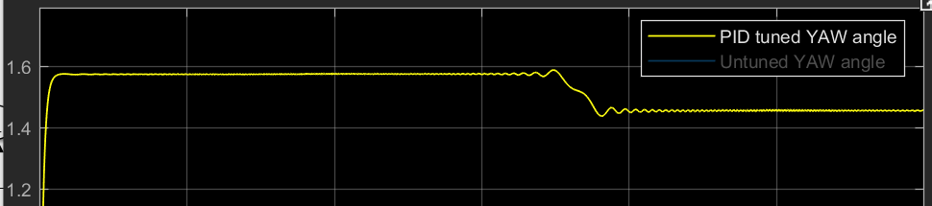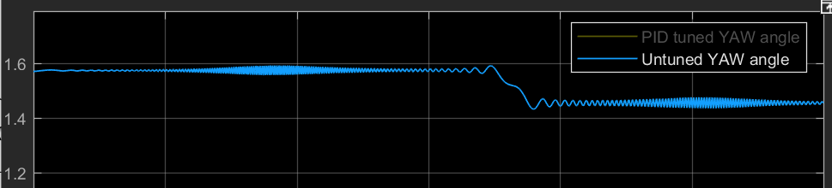

(a)

(b) (c)

(d) (e)

**2) PID for System Damping**

As subfigure 2-7 (b) and (c) show, the yaw angle is seperated from Euler angles is tuned for eliminating vibrations.

**3) Decoupled PID controller Design (Failed)**

The three angles are coupled then I tried to use the separate PID controllers to decouple them at the first time

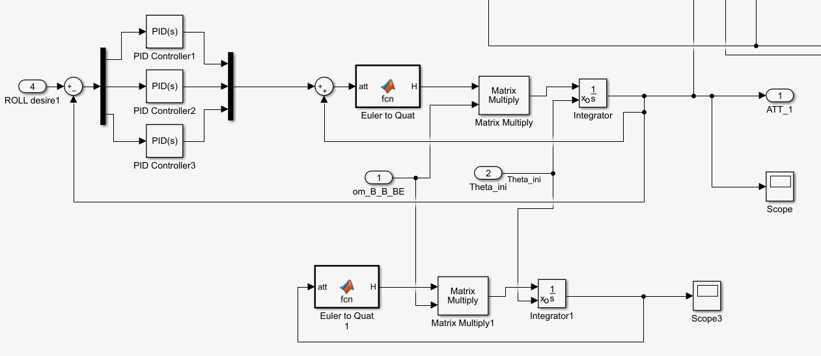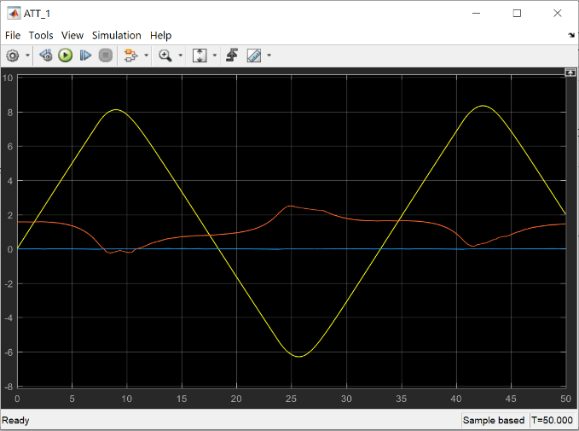

Figure 2-8. Control System

*Supplement

Controllability and observability check using Gramians in MATLAB

By using the gram() command in matlab, it has the limitation of A as A’s all eigenvalues have negative real part in continuous time, and magnitude strictly less than one in discrete time. However, we have unstable eigenvalues in the A which may infect the results of ‘gram’

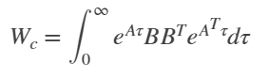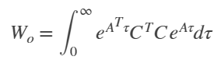

The controllability Gramian is positive definite if and only if (A, B) is controllable. The observability Gramian is positive definite if and only if (A, C) is observable. However, the Gramian of system controllability and observability have negative parts and evenly contributed, which make the Gramian check for system impossible.

Chapter 3: Model Trim and Linearization

3.1 Model Trim

By using Linear Analysis in Simulink, the twelve states could be trim to linearize the outputs. After discussing with teammates, we decide to trim these seven states: [Alt, Phi, Psi, V, P, Q, R]

3.1.1 Model Trim (without aero surface)

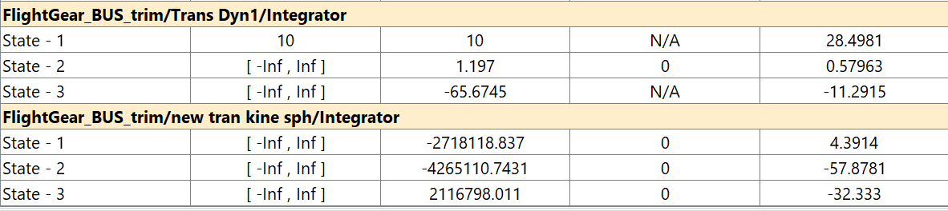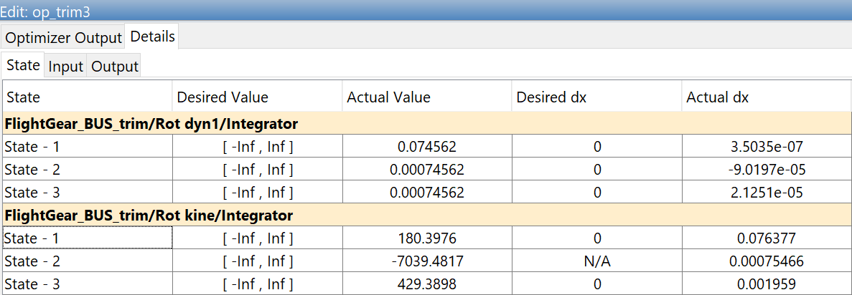

Figure 3-1. Linear Analysis Trim States

The results are showed below. The trimmed states are much linearized than untrimmed one. To be more particularly, the final simulation results have changed.

From figure 3-2, the trimmed model results can be much more stable and linearized.

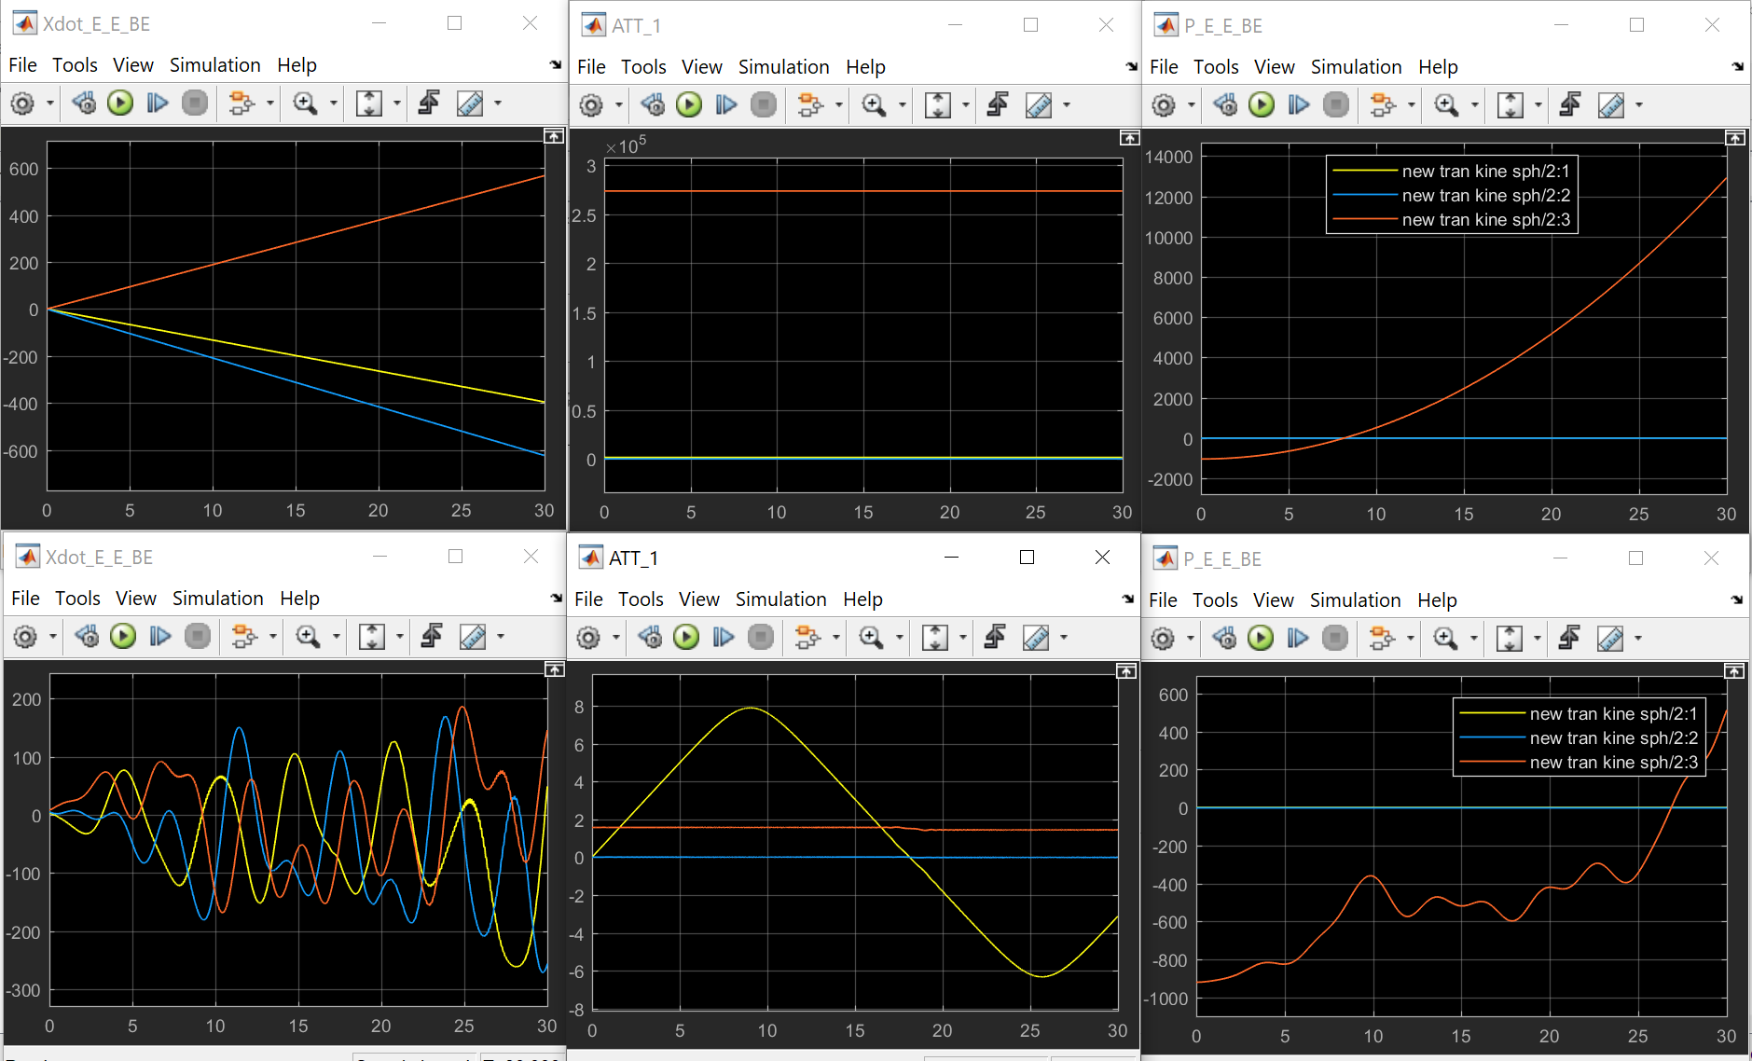

Figure 3-2. Trim Results (up: trimmed; down: untrimmed)

3.1.2 Model Trim (with aero surface)

After applying the aero surfaces into the system as the figure 3-3 shows, however, for both states

Figure 3-3. Trim Results (up: trimmed; down: untrimmed)

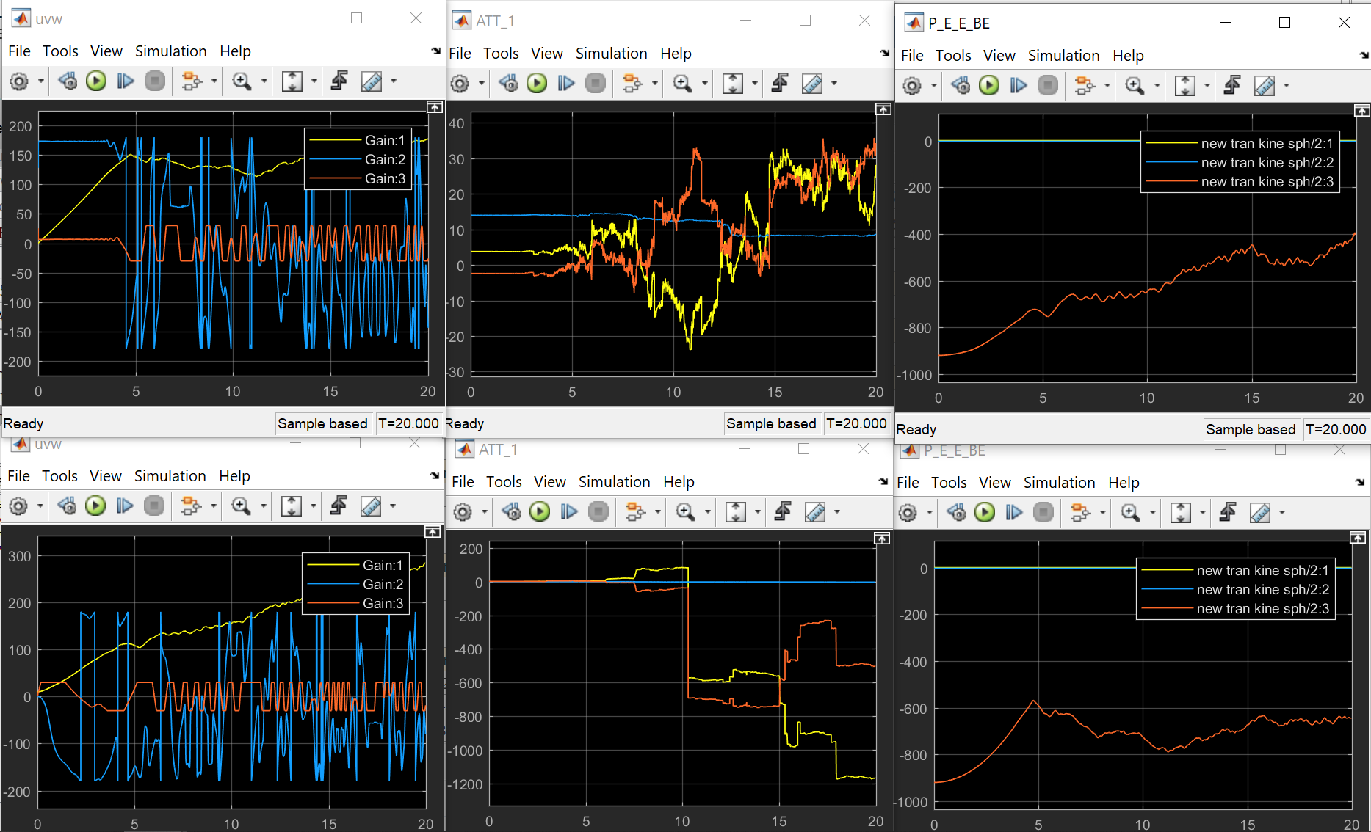

3.2 Model Linearization and Steady-state Flight

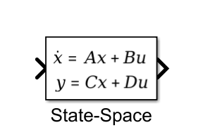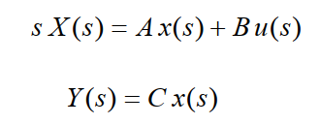

Figure 3-4. State-space equations

A simple analysis of a generalized multiple-input-multiple-output (MIMO) system is using Laplace transform for the state space system(left) and setting the feed forward term to zero (right). The system matrices in the certain initial conditions are listed below.[4]

Figure 3-5. Initial A and B matrix (False)

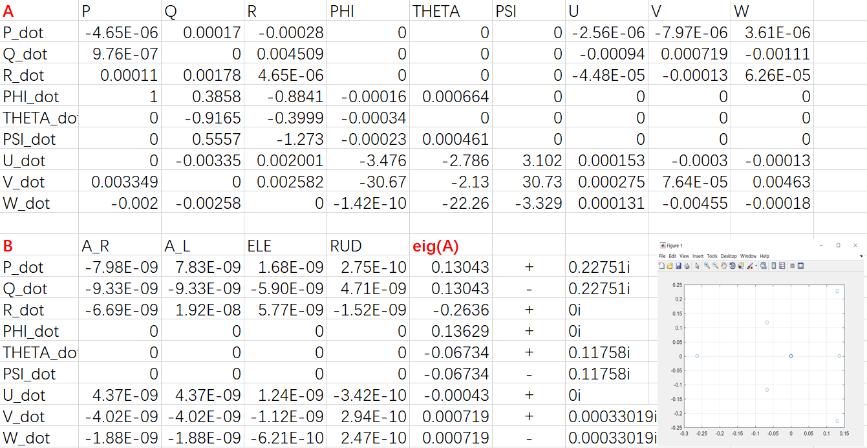

3.3 Linear States Analysis

3.3.1 Aircraft Dynamic Stability Analysis

**1) Dutch Roll Mode**

Through the eigenvalues of A matrix, we could have the following modes:

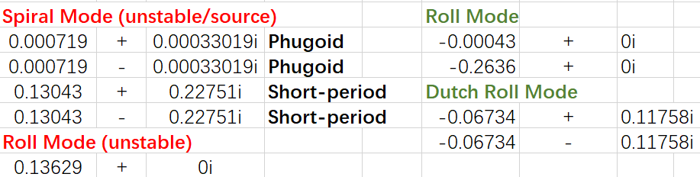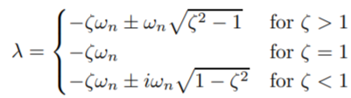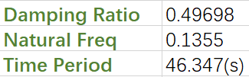

Figure 3-6. Flight Mode Analysis

The Dutch Roll Mode can be excited by aircraft rudder produces both rolling andyawing moments. By using eigenvalue mathmatical methods, the time period and damping ratio are 46.347s and 0.49838, which means the dutch roll period is quiet long with large oscillation damped.

**2) Roll Mode (stable)**

In the first order system, the roll modes incliding (2 305.5s) and fast roll response (3.7936s)

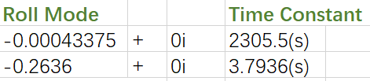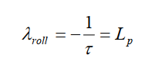

Figure 3-7. Time constant calculation

**3) Linearized Matrix Analysis**

From the A matrix linearized from the non-linear system, the Q_dot could never change Q, which may cause lots of problem like we could not control the pitch angle while running the system. In the next section the system would be optimized and re-linearized as to change it’s behavior.

3.3.2 Lateral/Longitudinal Motion Control

For this section, PID controller design is applied to optimize the dutch roll mode parameters for faster rudder response. As we all know, analysis of MIMO (Multiple-input-multiple-output) systems using basic loop shaping techniques, especially for root-locus analysis, requires that only one loop at a time can be closed. From the figure, the inner loop of [rudder-R] is designed to damp the Dutch Roll Mode and the root-locus could be used for closed loop gain selection due to different damping coefficient.

**1) Linearized System and Behavior Analysis**

By relinearize the [Rudder-R] system with PID controller and ‘wash out’ blocks, we have A matrix and eigenvalues as the figure 3-8 shows.

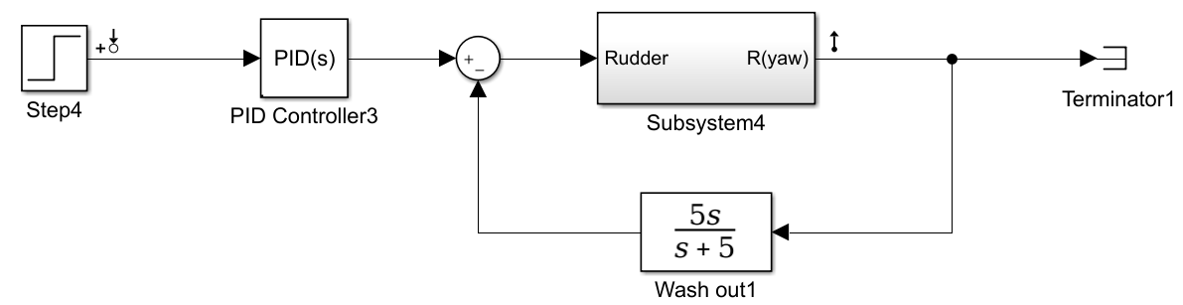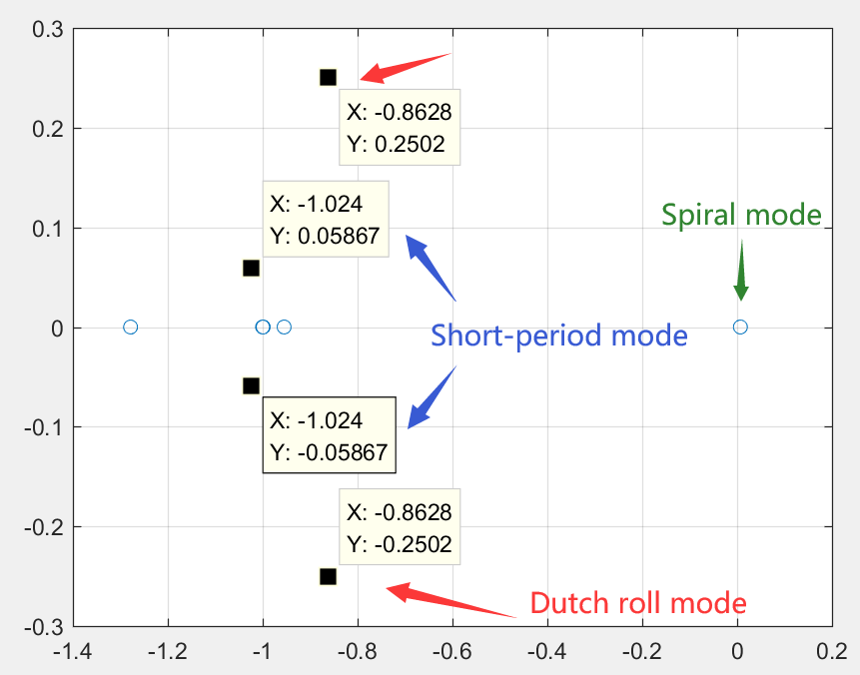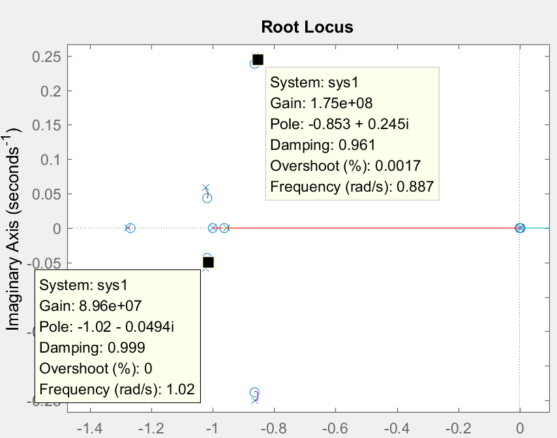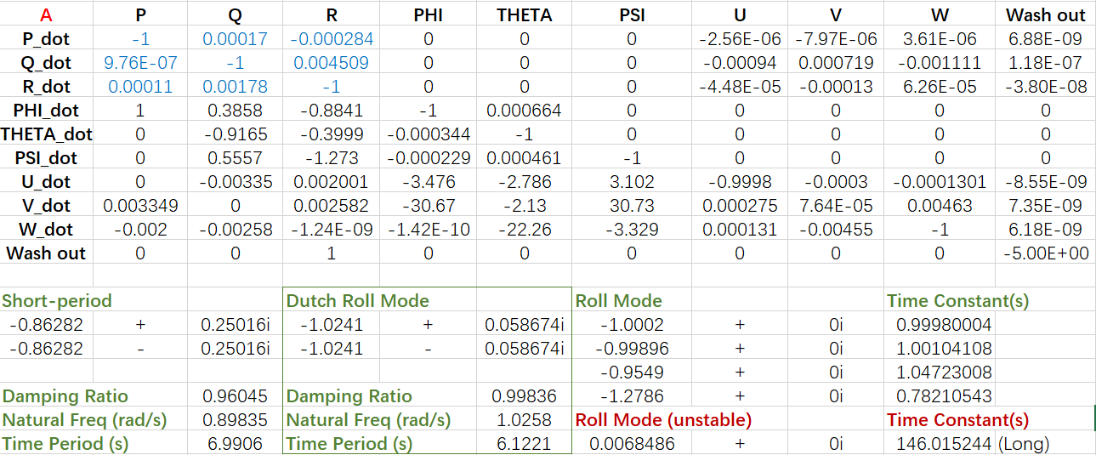

Figure 3-8. Dutch Roll Mode Analysis

From the eigenvalues plot graph comparing with rlocus graph, the Dutch roll mode/roll mode behaviors pole distributions are corresponding to each other. However, through the rlocus plot, there’re not enough adjusting range for both Dutch roll and roll mode behaviors.

In addition, for this ASW28 case, the Dutch roll mode and roll mode have similar large damping ratio and time period.

**2) Aero-surface Control**

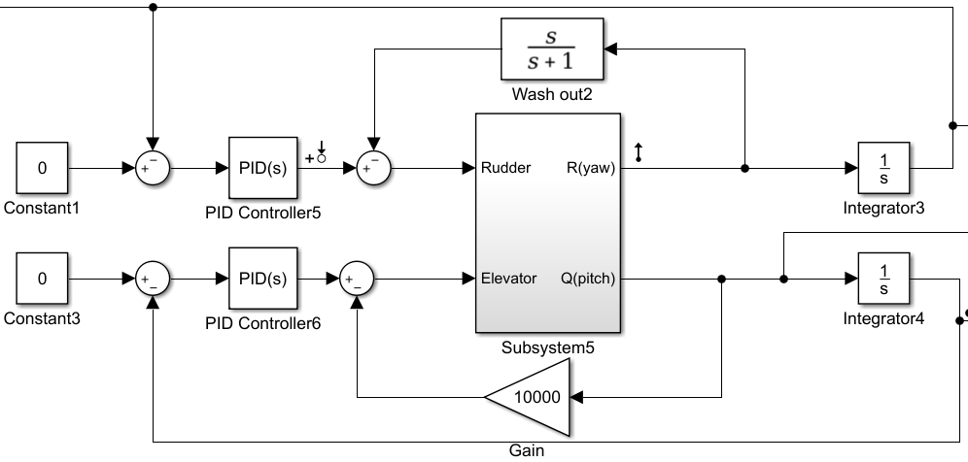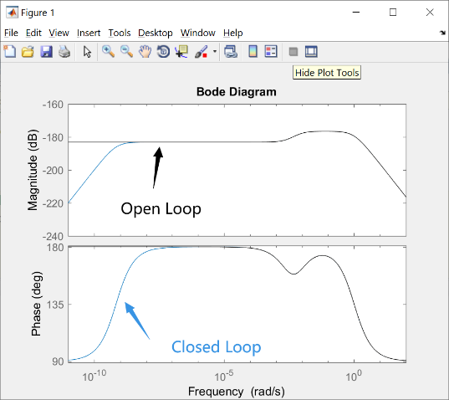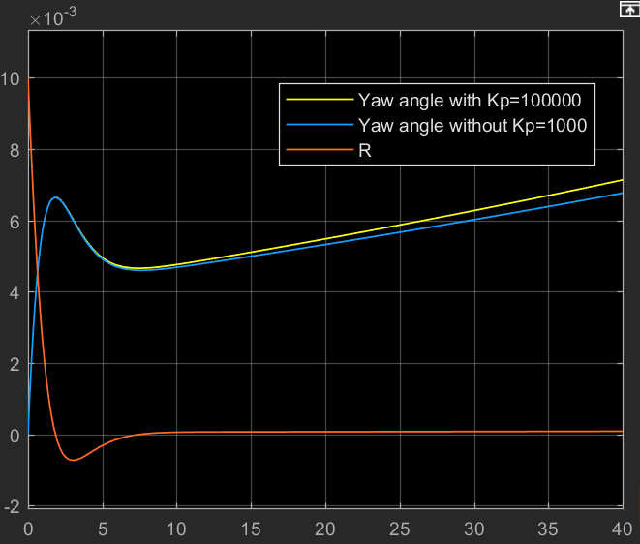

Figure 3-10. Trim Results (up: trimmed; down: untrimmed)

Figure 3-9. Aero surface control

By adding the first order actuator into the linearized system as the figure below shows, the system yawing angles can respond to the rudder paddle changes in a linearized way.

According to the book, much higher gain will demand excessive control deflection rates of rudder and the gain will be designed due to rlocus and multiple tries. Also from the Bode diagram figure and comparing figure for the [rudder-yaw] the ‘wash out’ as it doesn't contribute much for the performance but adding a roll mode with short time constant (The wash out pole set to be ‘-1’). The outer loop.

Figure 3-11. Aero surface linear control for Roll Pitch and Yaw (left to right)

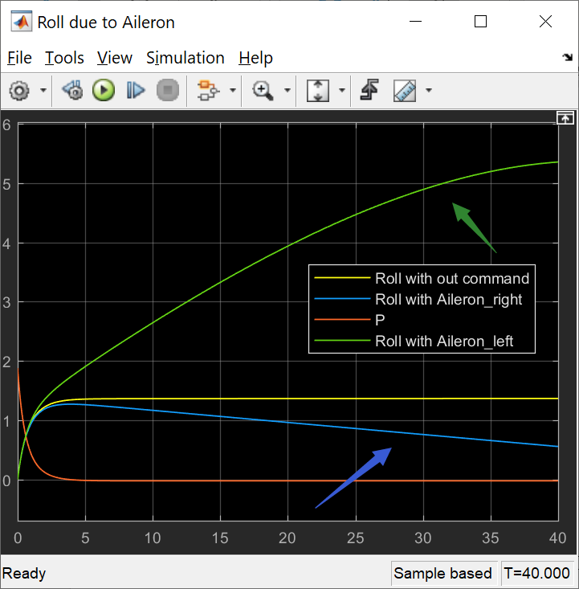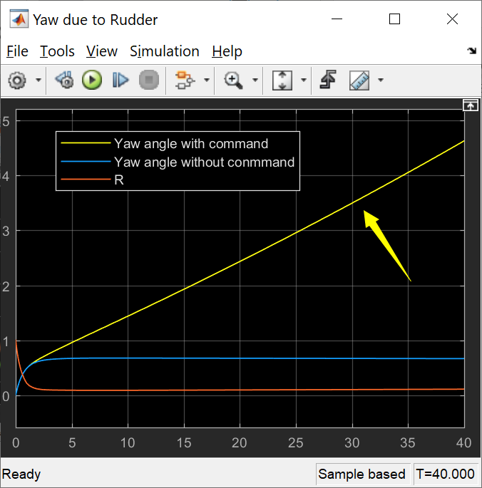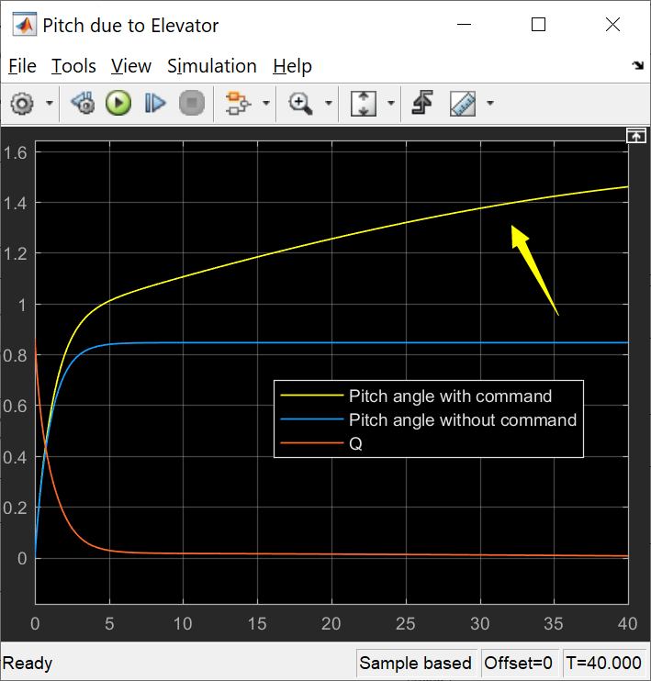

From the [SISO] system, with certain command applied into the aero surfaces, the euler angle would linearly response to it. However, in real linear control system, we need to

**3) System Control Loop Tolerance**

The tolerance of system can be determined by input command size range. From the figure, curves may start to slowly decreasing due to the large command size.

With fixed PID controller, by changing the pilot command size of the separate loop system for Euler angles, the best command ranges are set to be:

* Aliron(left): [10000-28000]
* Elevator: [15000-21000]
* Rudder: Larger command, faster response

**(4) Basic Theory**

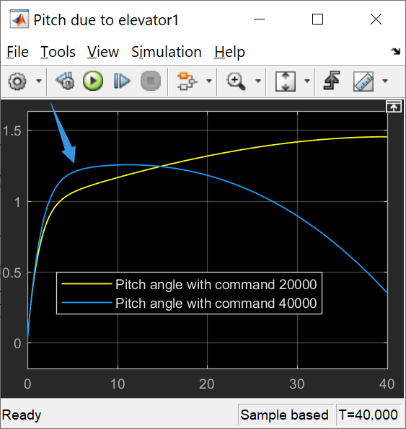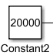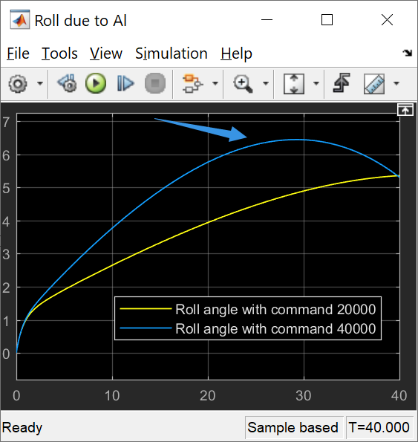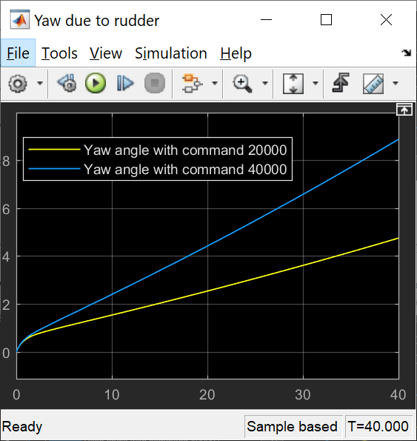

Figure 3-12. Command Size Comparing

(why PQR are controled for angle computations)

Using [Elevator-pitch] block, form the curve comparison the yaw angle we use dirrectely from 9 states output may is not start from 0 and have a sudden slope which is not perfect. Also we could place the intefral in the loop for control design

First order actuator added for slowly increased command performances

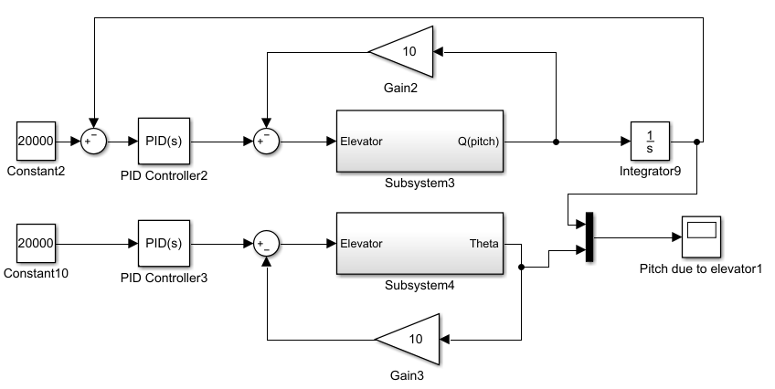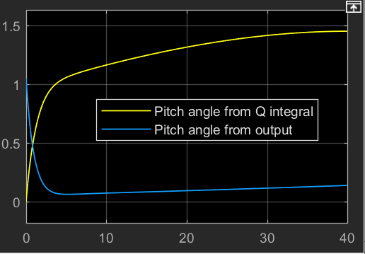

Figure 3-13. Trim Results (up: trimmed; down: untrimmed)

on both sides work as the sensor in deefback loop. From the different Kp applied in the loop, the yawing angle with change along it with different speed, from which, we could control the

3.3.2 Linear Controller Design

**1) Step Input for V**

For the linearized system, the step input and PID controllor[6] are applied to ‘V’ state in three conditions:

(a) No step input

(b) Step magnitute =10; step time =5.

(c) Step magnitute =10; step time =5; PID saturation limit =5.

As (c) shows, the PID saturation can set the limit to the output (from 10 to 5). It may also works on the angle range.

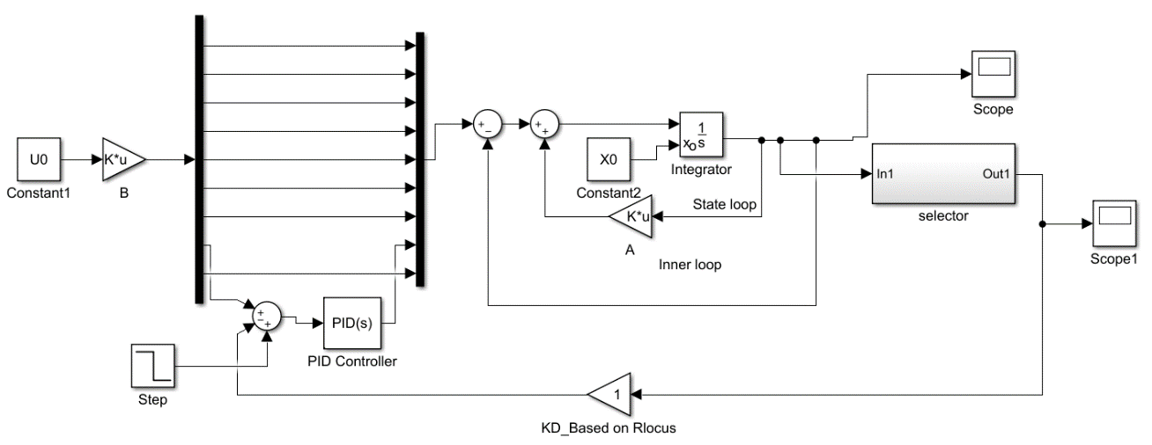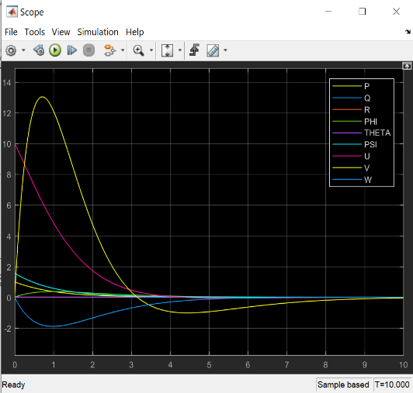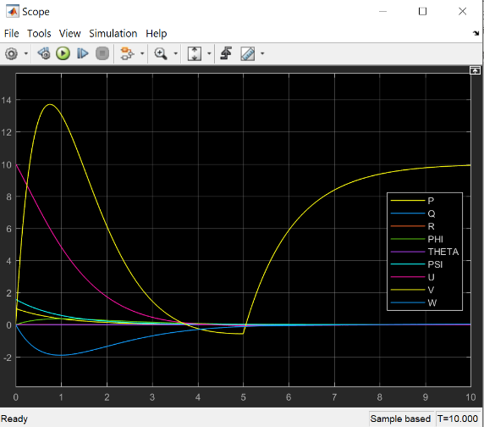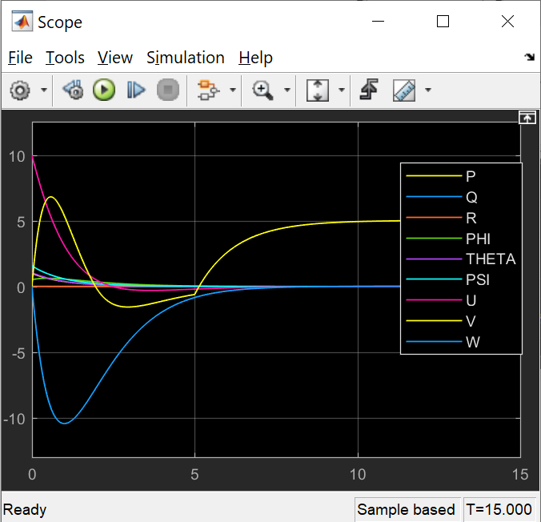

Figure 3-15. Set up conditions

(a) (b) (c)

Figure 3-14. Linear block diagrams

**2) PID design for ‘V’**

(a) [Kp, Ki, Kd]=[1,0,0]; Step=5 at 5sec

(b)[Kp, Ki, Kd]=[100,0,0]; Step=5 at 5sec

(c)[Kp, Ki,Kd]=[100,0,0]; Ramp=1 at 5sec

The system with different PIDs could response differently.

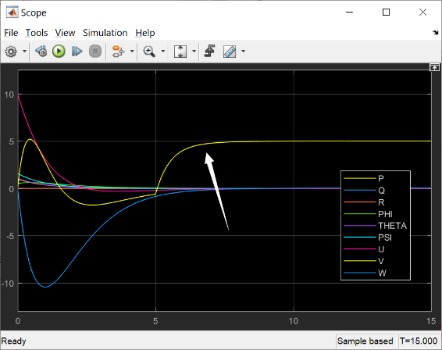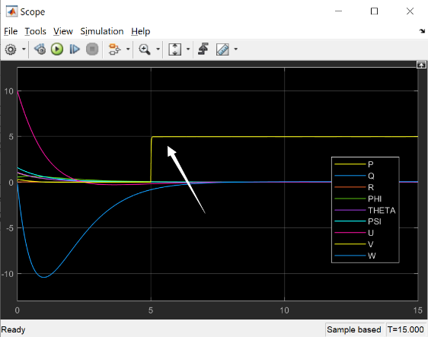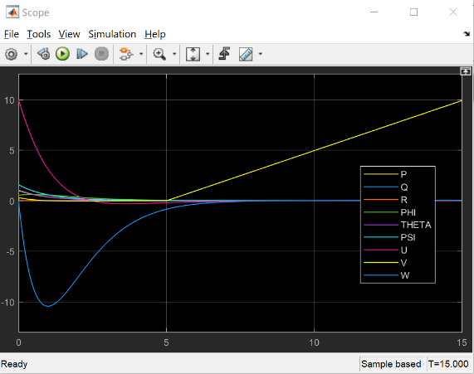

(a) (b) (c)

Figure 3-16. Linear System Behaviors due to input and PID

**3) PID Design for Coupled Parameters**

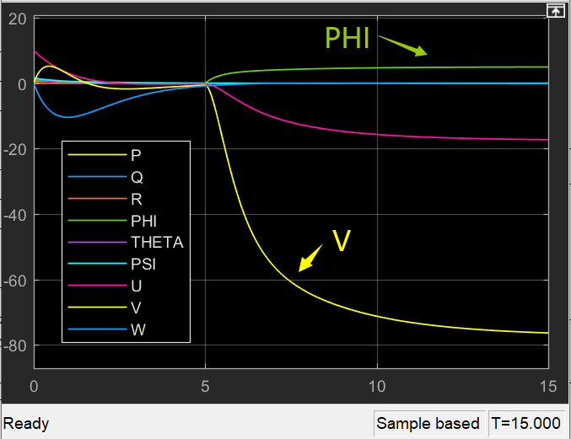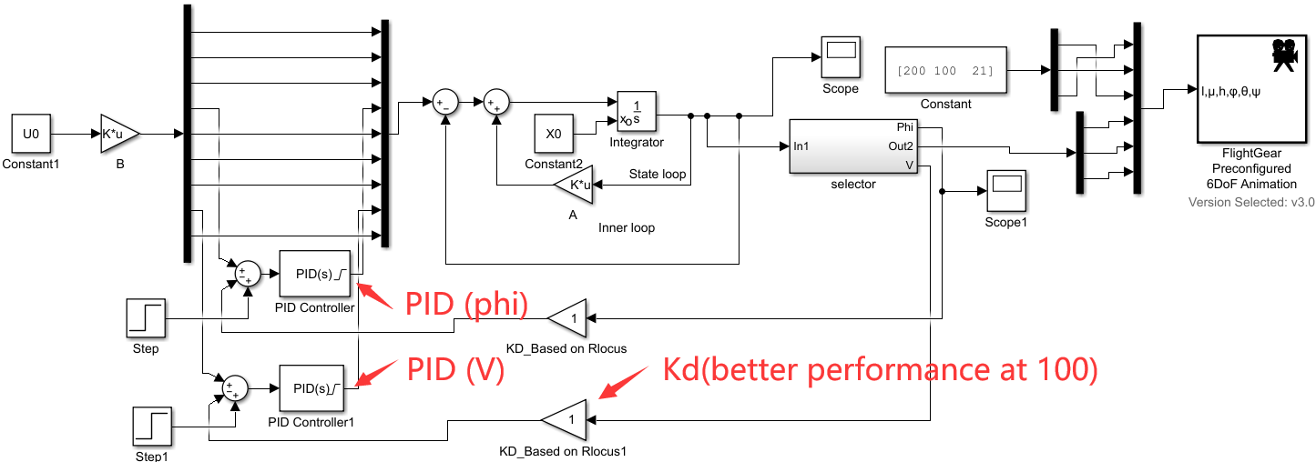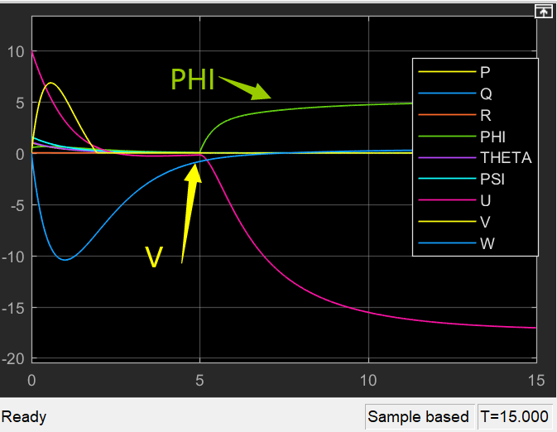

Figure 3-16. [PID applied to phi] [PID applied to phi and V]

3.3.3 LQR for Full Linearized System

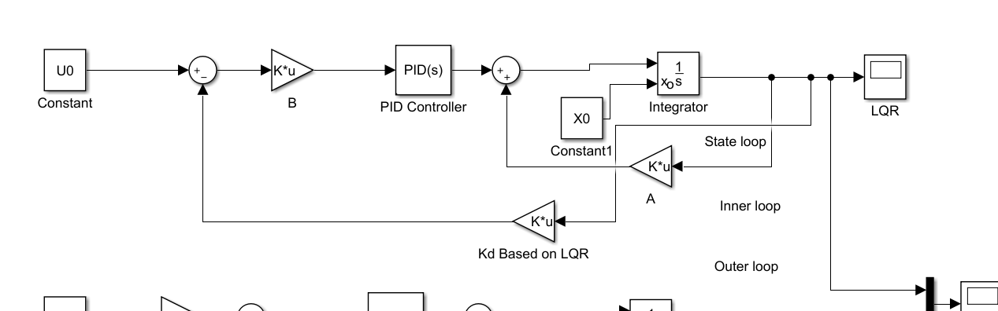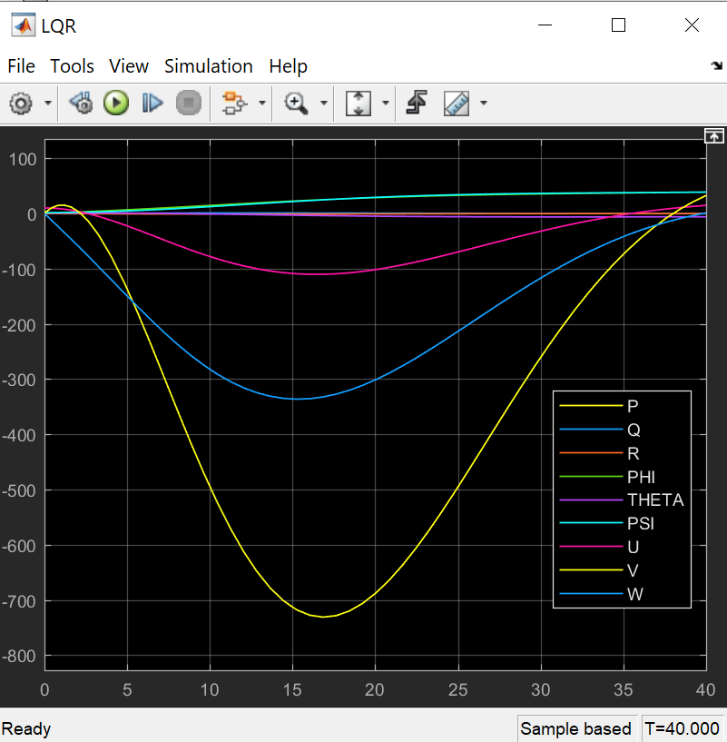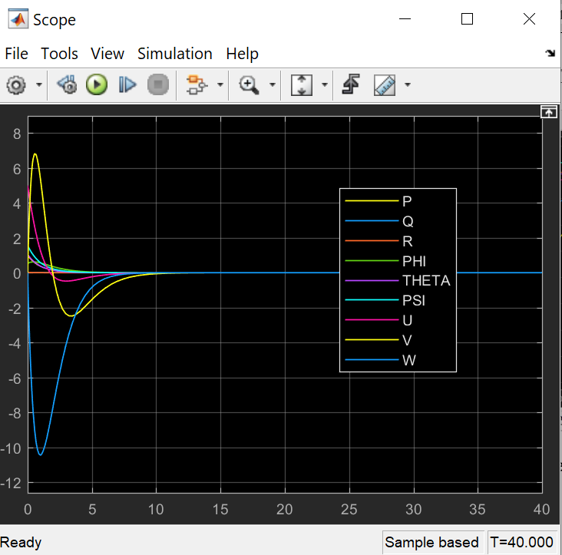

Figure 3-17. LQR applied(left); Without LQR(right)

3.4 Discrete Linearized System

3.4.1 System discretization in Simulink

By using the command ‘*sldiscmdl('Discrete_rudder_system',0.01,'zoh')*’, the SISO system, including input and output can be discretized. The sampling time is 0.01and the method is ‘Zero Order Hold’

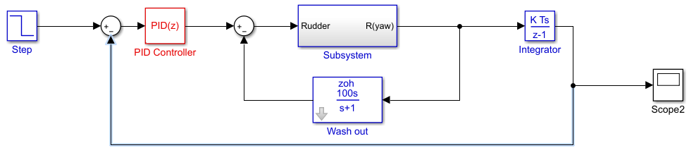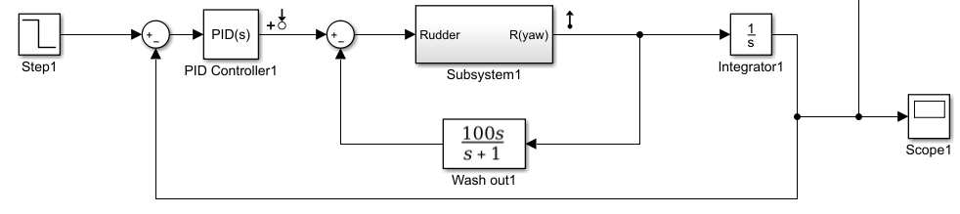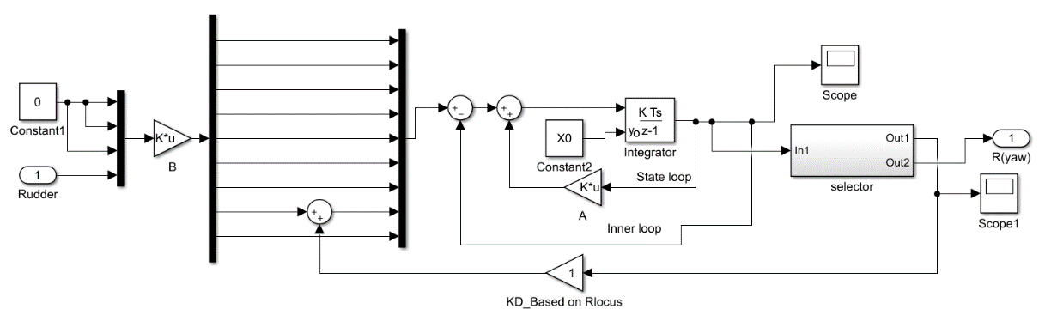

Figure 3-18. continuous-time model(up); Discrete-time Model(middle); Subsystem(down)

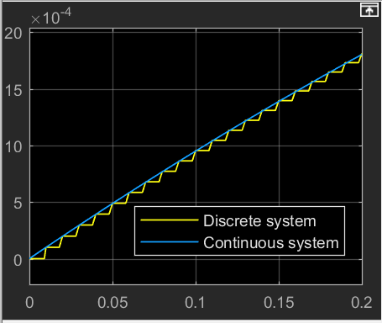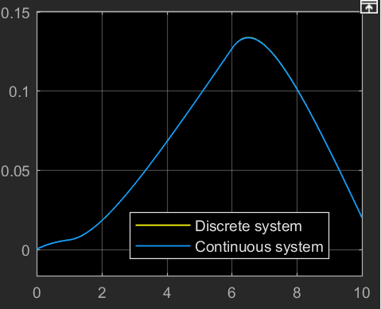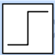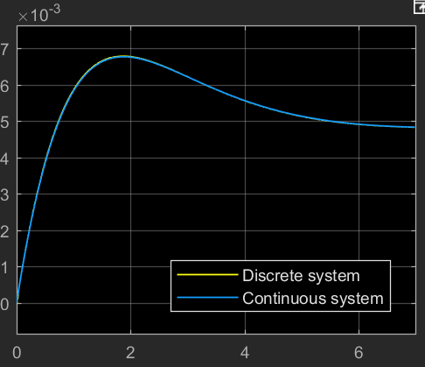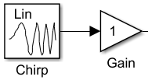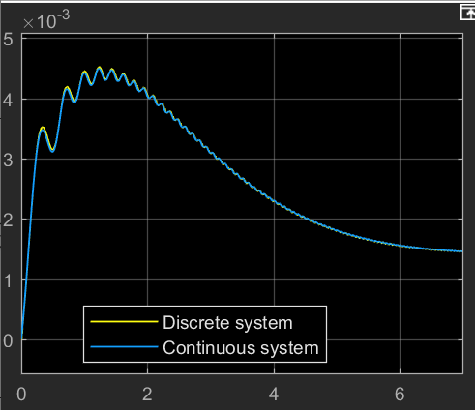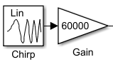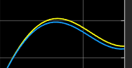

Figure 3-19. System Response to Step and Chirp signals

Chapter 4: ASW28 Flight Dynamic Analysis

4.1 Introduction

In this chaptar, the dynamics flying parameters are set as table-1. The bank and attack angle in ANSYS- fluent are set to be all ‘0’

Table 4-1: Flight Environment Parameters

|  |  |  |  |  |
| --- | --- | --- | --- | --- |
| Model Name | Velocity(m/s) | Temperatue(ºF) | Altitute(m) | Air Density(kg/m^3) |
| ASW28 | 400 | 77 | 1000 | 1.074 |

4.2 XFLR5 Dynamic Analysis

4.2.1 Model Design

The model uses NACA 2412 data for main wing and elevator section and NACA 0009 for ruder section.[5] By choosing proper sweepback angle and taper, the coefficients change along different alpha degree(-1.5 to 30 [deg])

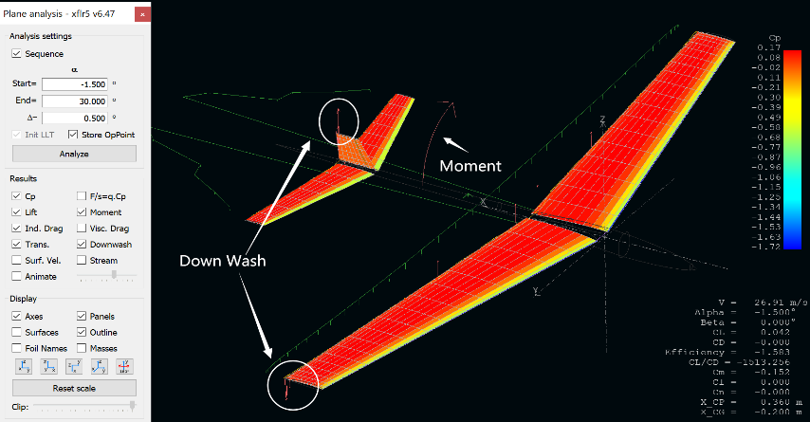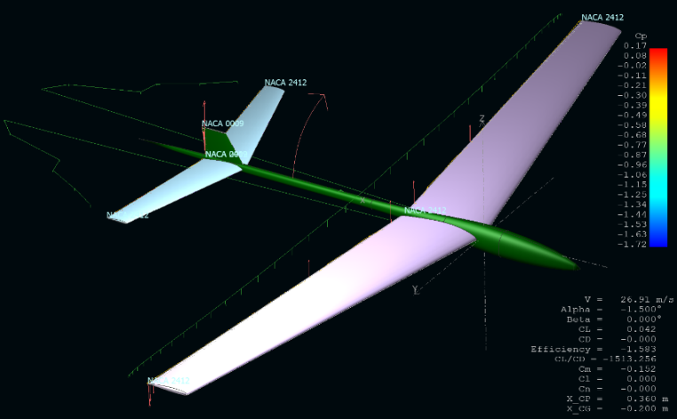

Figure 4-1 XFLR5 Analysis.

4.2.2 Dynamic Coefficient Calculation

The figure 4-2 below shows without offset points. The aero coefficients shows different coefficients distribution. However, from the [Cl-alpha] curve, we could the slope remains unchange which is not very similar to the real situation. In addition, the dynamic data calculated from XFLR5 can not fit the ASW28 model we used for the main project calculation.

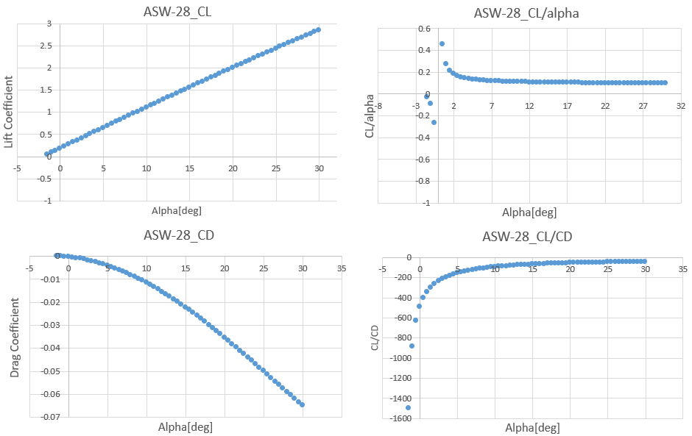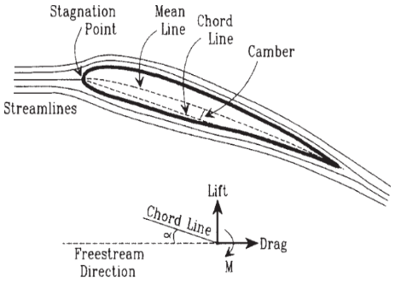

Figure 4-2. Definitions associated with an airfoil and Dynamic Coefficients

4.3. ANSYS Dynamic Analysis

4.3.1 Finite Element Analysis

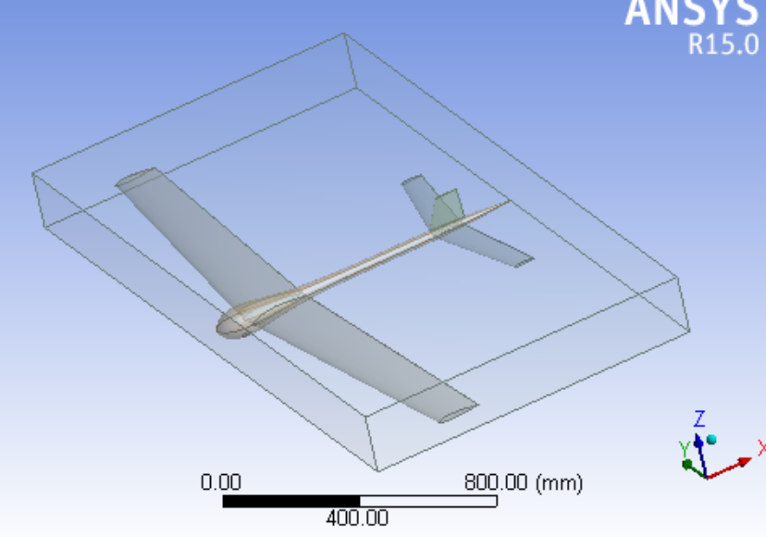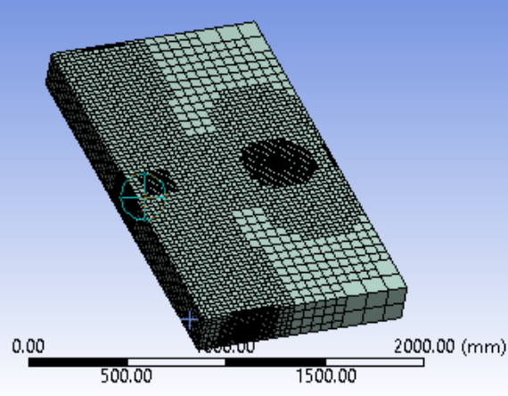

Figure 4-3 FEA on ASW28

By use ANSYS FLUENT module(as figure 4-3 shows), the FEA analysis is applied to the whole ASW28 exported from XFLR5

4.3.2 Aerodynamic Distribution

**1) Pressure Distribution**

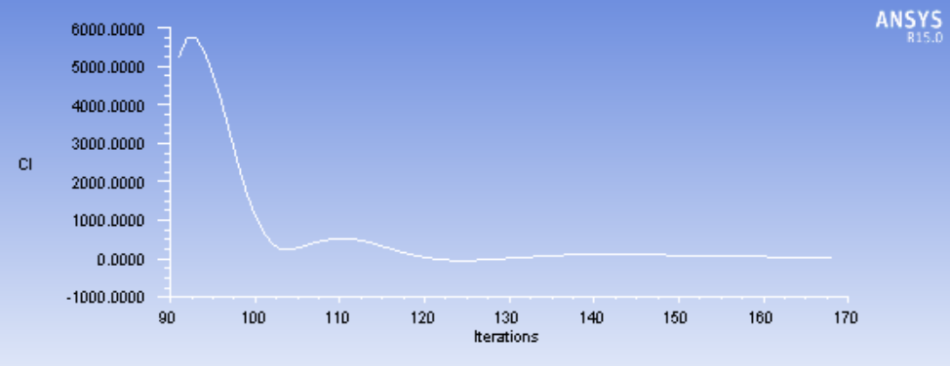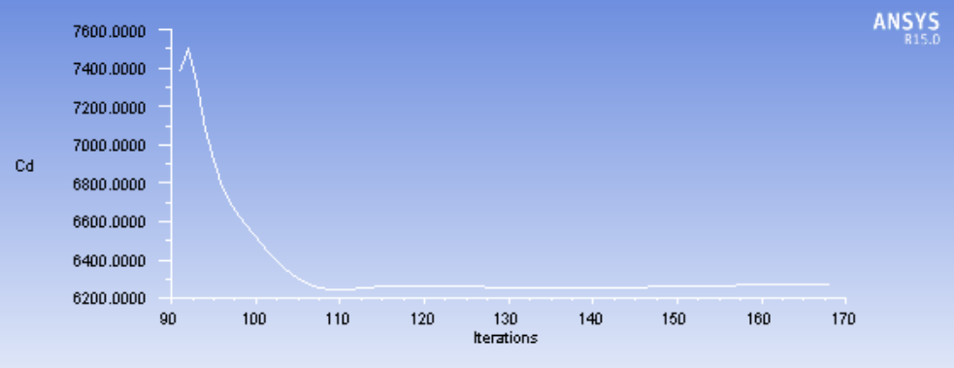

Figure 4-4 Cl, Cd and pressure distribution.

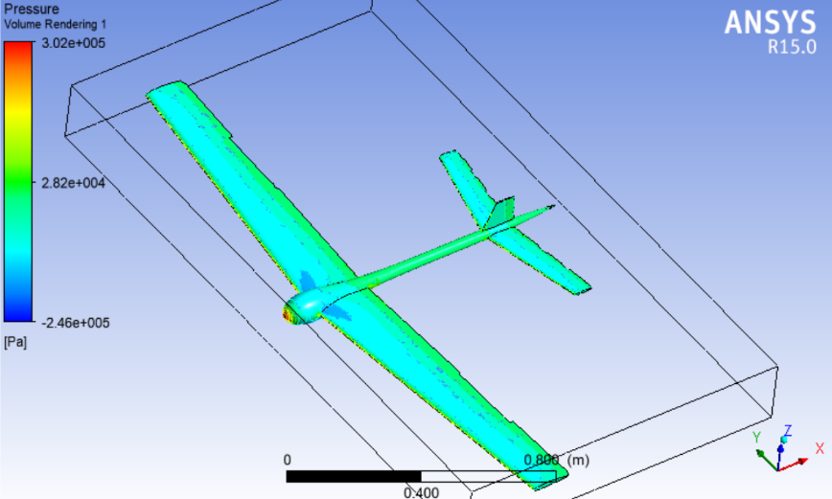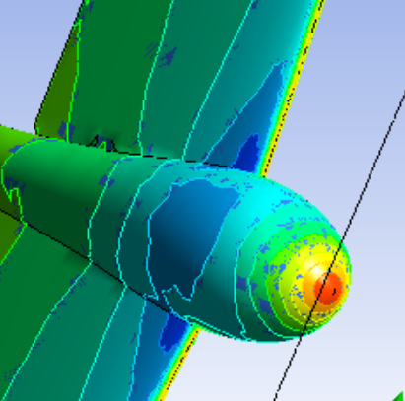

We could see it clear among the cephalic cone and connection parts between body and wing. As the influences of ailerons are ignore in the fluent analysis, the pressure among the aero surfaces remain indifferent.

**2) Velocity Distribution**

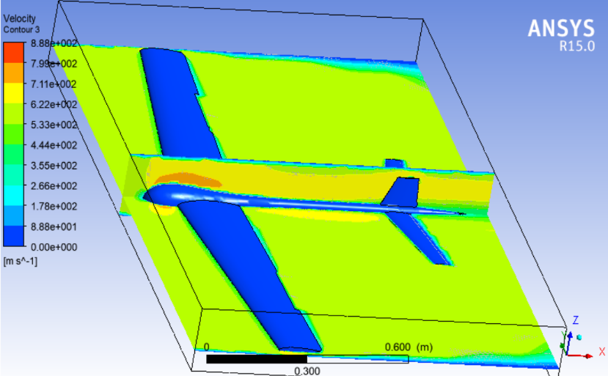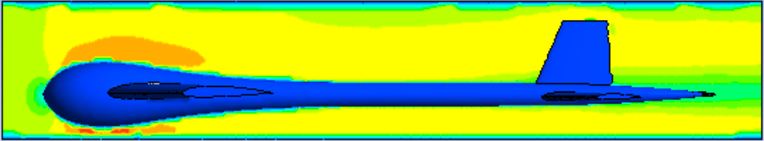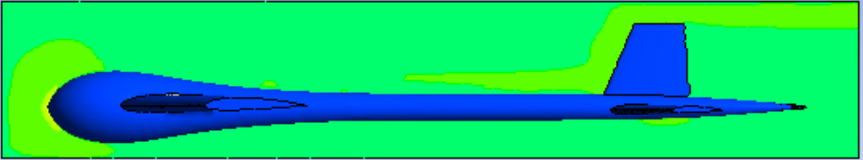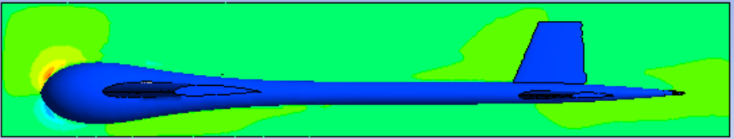

Figure 4-5. Velocity Contour (left); [u; v; w] in Longitudinal Symmetry Plane

Among the (lateral and) longitudinal symmetry plane velocity distrubution, the “u” velocity has the largest component of the velocity.

Chapter 5: Simulation

5.1 Simulink to FlightGear

The block in aerospace basket is used to conneck MATLAB Simulink to FlightGear for better performance simulated[9].

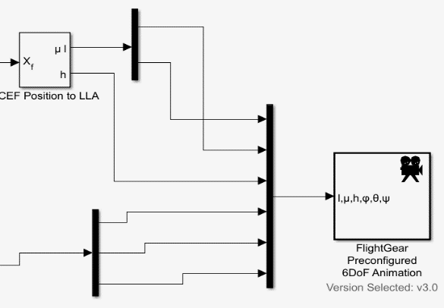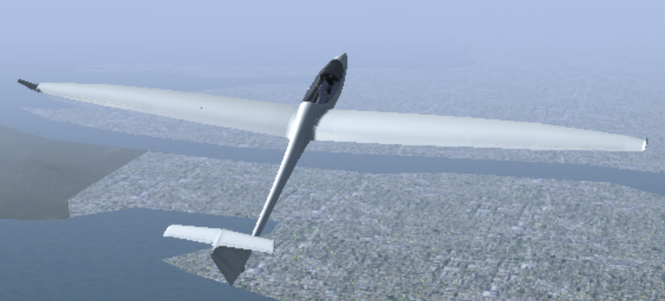

Figure 5-1. Definitions associated with an airfoil.

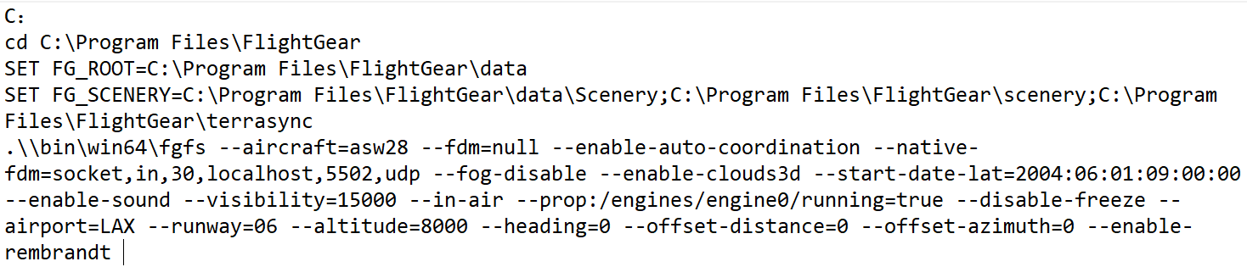

Figure 5-2. Definitions associated with an airfoil.

For flight control

This could be a PID controller with the input from your current roll and a reference of zero. Output should go to your aileron-cmd.

5.2 Maneuver in Steady-state Flight

5.2.1 Pilot Control Simulation

Adding time delay to the system provided a very characteristic response for a

system that has a human in the loop. The noise are also added for better situation simulated[10].

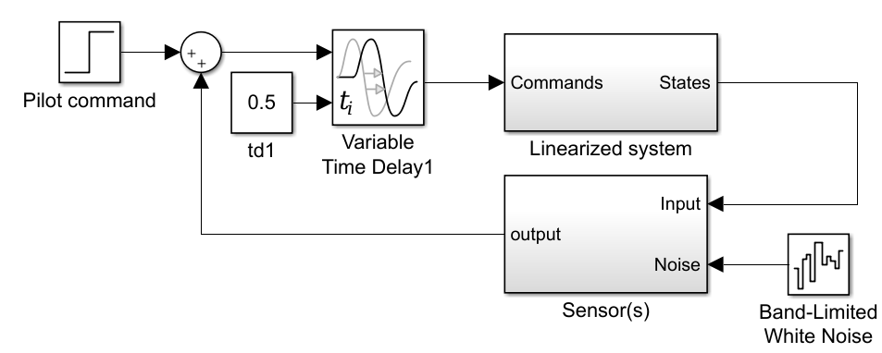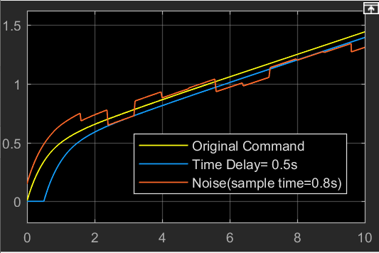

Figure 5-3. Pilot Control System.

5.2.2 Skid to Turn

**1) Skid to turn Theory**

Skid-to-turn is an aeronautical vehicle reference for how such a vehicle may be turned. It applies to vehicles such as aircraft and missiles. In skid-to-turn, the vehicle does not roll to a preferred angle. Instead commands to the control surfaces are mixed to produce the maneuver in the desired direction.

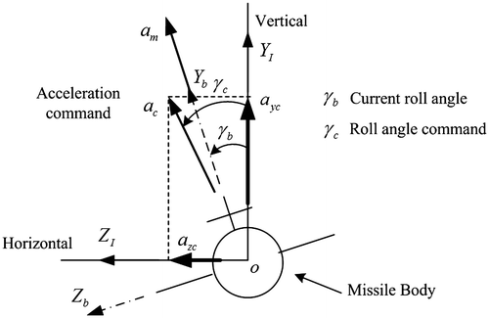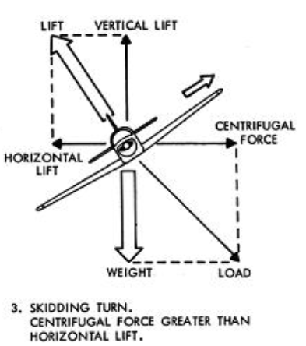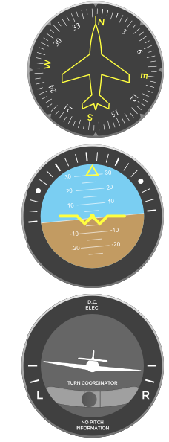

Figure 5-4. Skid to turn Theory.

Linear analysis of the system provides a good starting point to consider design modifications that would allow ASW28 to perform skidding turns better.

**2) SISO System control**

If we seperately contol the [SISO] system, the euler angle behavior would be the figure below.

From figure 5-5, the

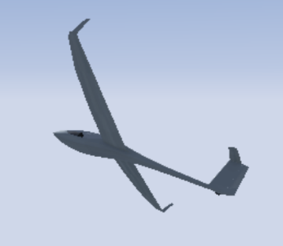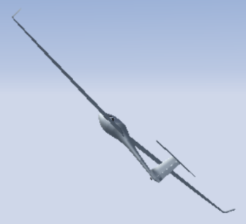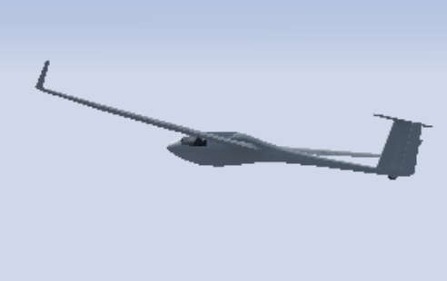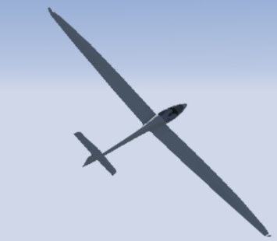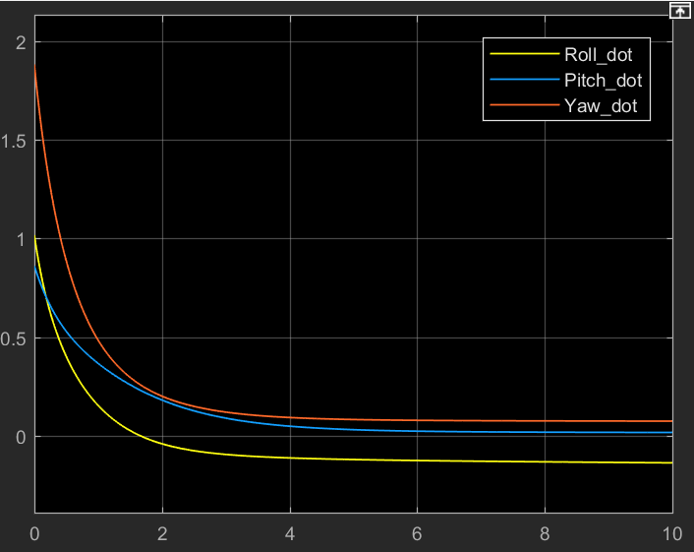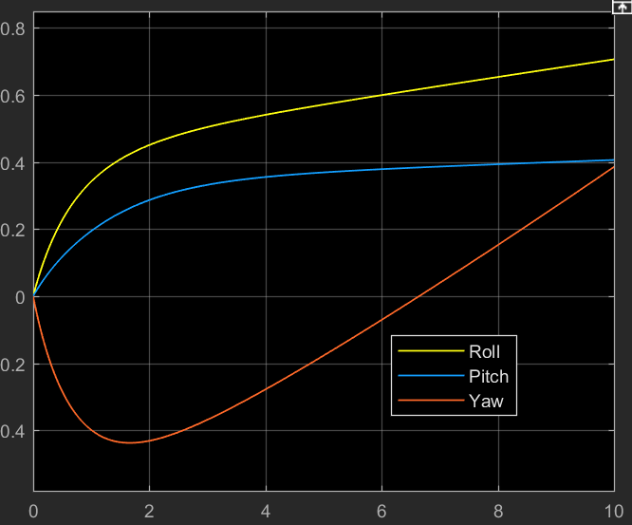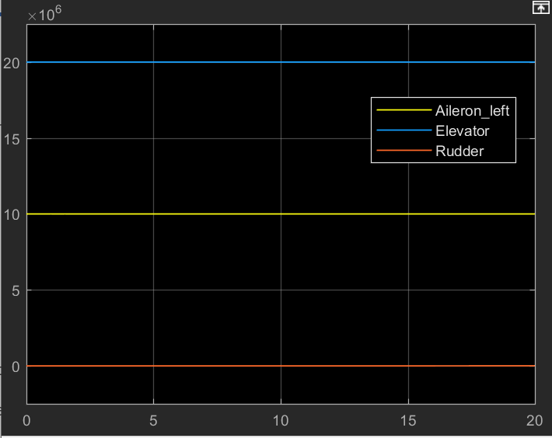

Figure 5-5. Pilot Control System.

However, the system is coupled and we could not simply decouple them by seperate the blocks. Also, the command control need to bring the aircraft back to the lateral stable position

**3) MIMO coupled system control**

In the MIMO system[11], larger Kp, faster turning point. Also command input control the curve slope and magnitute. However, as the three of them is coupled, the step input applied to one of the angles may affact others:

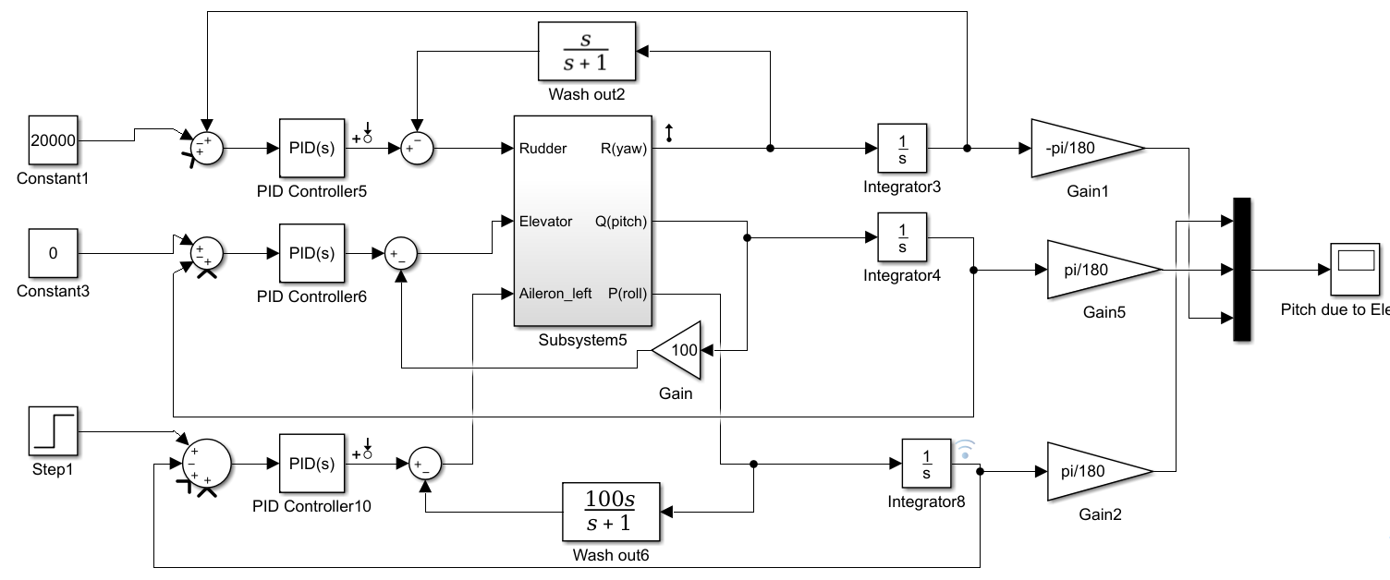

Figure 5-6 Coupled Linear System

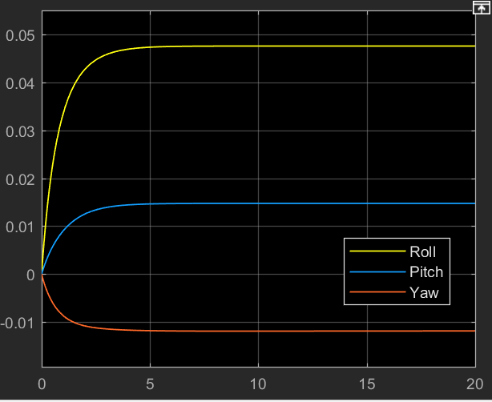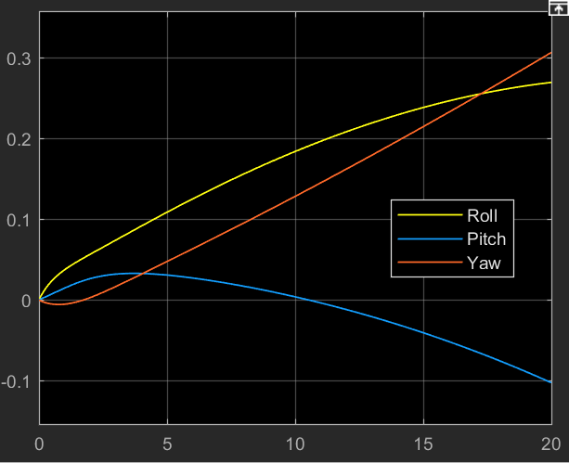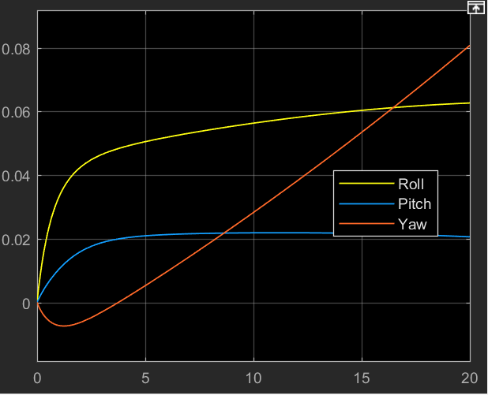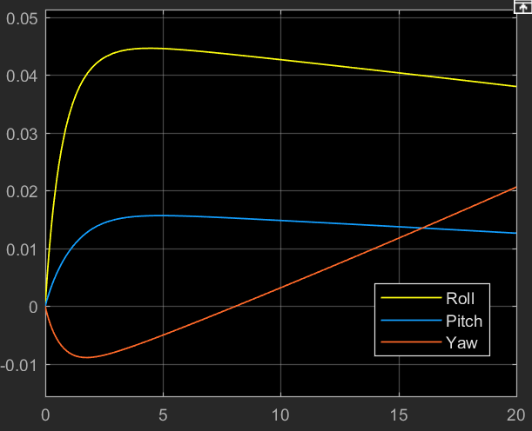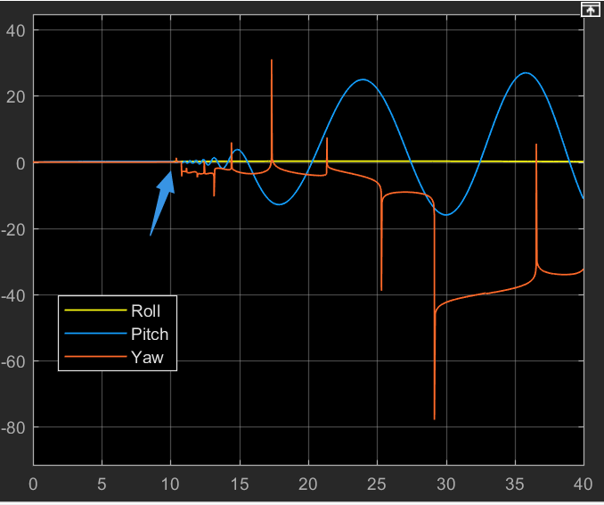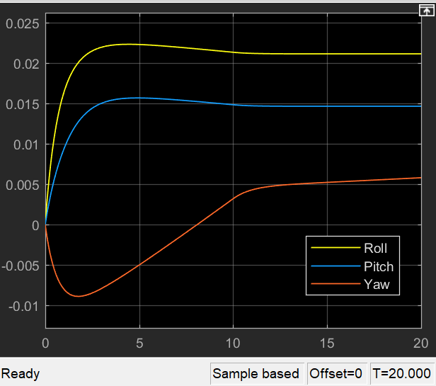

Figure 5-8. [No signal] [adding large signal to elevator] [Command and Step input attached to rudder]

Figure 5-7. [Aileron_left command = 65000] [Elevator command=40000] [Rudder=20000 ]

**4) Skidded turn in FlightGear**

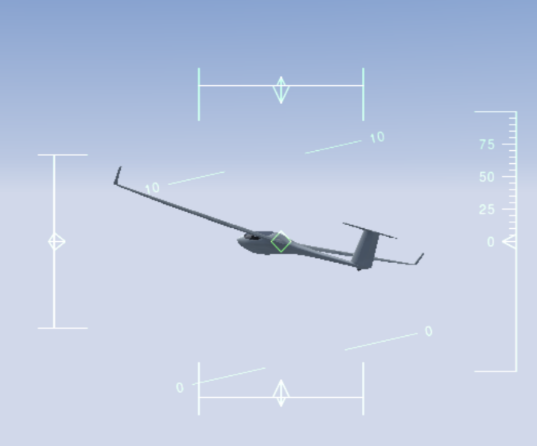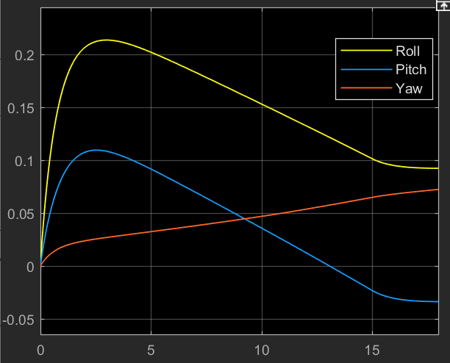

Figure 5-9. Skid to turn in coupled linear system.

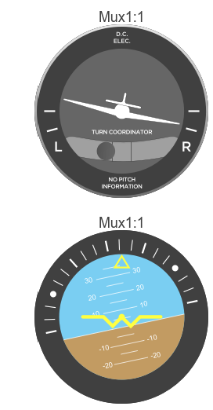

After applied almost equivalent Aileron and Rudder commands to the MIMO system, the ASW could achieved small angle ‘skid to turn’ for the whole process about 15 sec then go back to a certain euler angles.

5.2.3 Slipping Turn

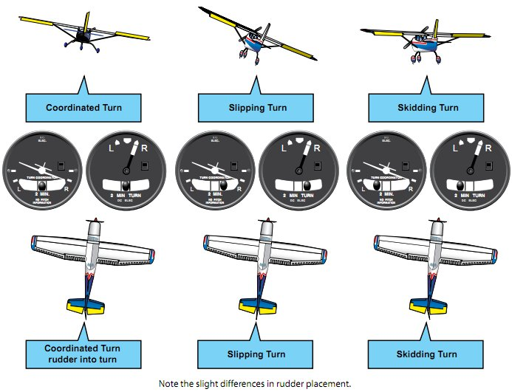

Figure 5-9. Skid to turn in coupled linear system.

Slipping is when the nose of the airplane is outside of the turn while the tail of the aircraft is inside the turn. In this situation the angle of bank is too great for the rate of the turn. You could correct it either by reducing your bank angle or by applying rudder to the direction of the turn. Happens when pilot applies too much rudder and give less aileron.

Conclusions

During the discussion above, the following conclusions are implemented:

**1)** The nonlinear system build on basic aerodynamic equations can be used for system design and coordinate transformation. The inner fouce and moment generated through ASW28 aerodynamic configuration, and propeller system is added in as well. Among the non-linear system, by tuning PID with certain parameters, controller, the system oscillations can be eliminated.

**2)** The system is linearized for dynamic stability analysis. By studying the eigenvalues of matrix A, the Flight Roll Modes can be tweaked by applying different Gains though Root-locus. The LQR design for the whole linearized system is also counted into discussion.

**3)** Through FEA aero dynamic analysis of ASW28 model, the pressure and velocity distribution overall Flow field and Aircraft Surface could clearly be revealed. In addition, the effects of wind tunnel on wing flow can be explored through this method.

**4)** Through commands applied to the linearized system aero surfaces, the coupled roll pitch yaw angles can be controlled to implement different performances. In this report, the skid to turn designed for ASW28 in the midair is presented through rudder and aileron synergetic efforts.

**To be continued:** This report leave several topics along such as ‘decoupling linearized system’, ‘System control in discrete time domain’, ‘LQT&LQG controller design’ ect.

References

[1].STEVENS, B.L., F.L. LEWIS and E.N. JOHNSON, Aircraft Control and Simulation Third Edition Dynamics, Controls Design, and Autonomous Systems, United States of America: John Wiley & Sons, Inc., Hoboken, New Jersey

[2]. Dr. Nelson, R.C., Flight Stability and Automatic Control 2nd Ed.

[3]. Kaloust, J., C. Ham and Z. Qu, Nonlinear autopilot control design for a 2-DOF helicopter model.

[4]. Chen, C., System Theory and Design. Second Edition ed: Oxford University Press.

[5]. Yechout, T.R., et al., Introduction to aircraft flight mechanics: American Institute of Aeronautics and Astronautics, Inc.1801 Alexander Bell Drive, Reston, VA 20191-4344.

[6]. Chambers, J.R. and R.M. Hall, Historical Review of Uncommanded Lateral-Directional Motions at Transonic Conditions. JOURNAL OF AIRCRAFT, (Vol. 41, No. 3, May–June 2004).

[7]. Rauf, A., et al. Aerodynamic modeling and state-space model extraction of a UAV using DATCOM and Simulink. 2011: IEEE.

[8]. Rysdyk, R., Course and Heading Changes in significant wind. JOURNAL OF GUIDANCE, CONTROL, AND DYNAMICS, (Vol. 30, No. 4, July–August 2007).

[9]. Michael Basler, M.S., et al., The FlightGear Manual for FlightGear Version 3.6.0.

[10].Kubica, F. and T. Livet, Flight Control Law Synthesis for A Flexible Aircraft. American Institute of Aeronautics, 1994.

[11] Tanner Austin Sims, Design and Control Considerations for a Skid-to-Turn Unmanned Aerial Vehicle, 2009

Useful links

How to dynamically change a block parameter value during simulation run-time?

<https://www.mathworks.com/matlabcentral/answers/334224-how-to-dynamically-change-a-block-parameter-value-during-simulation-run-time>

<https://www.mathworks.com/help/releases/R2017a/simulink/ug/using-tunable-parameters.html>

<https://uk.mathworks.com/help/simulink/ug/tune-and-visualize-your-model-with-dashboard-blocks.html>

Send fdm to flightgear

<https://www.mathworks.com/help/aeroblks/sendnet_fdmpackettoflightgear.html>

<https://www.mathworks.com/help/aeroblks/sendnet_fdmpackettoflightgear.html>

<https://www.mathworks.com/help/aeroblks/packnet_fdmpacketforflightgear.html>

<https://www.youtube.com/watch?v=jB-80cvV1Ao>

<https://forum.flightgear.org/viewtopic.php?f=36&t=32707>

<https://www.mathworks.com/help/aeroblks/packnet_fdmpacketforflightgear.html>

S function/UDP

<https://www.mathworks.com/help/simulink/sfg/sim-viewing-devices-in-external-mode.html>

<https://www.mathworks.com/help/simulink/sfg/example-of-a-basic-c-mex-s-function.html#f8-82449>

<https://www.mathworks.com/help/aeroblks/packnet_fdmpacketforflightgear.html>

<https://www.mathworks.com/matlabcentral/answers/309926-matlab-udp-recieve-error>

Simulink Animation

<https://www.mathworks.com/videos/modeling-simulation-and-flight-control-design-of-an-aircraft-with-simulink-81546.html>

<https://www.mathworks.com/products/aerospace-toolbox.html>

ANSYS FLUENT

<https://www.youtube.com/watch?v=2x1Qx15pzm0>

<https://www.youtube.com/watch?v=HGzcVkDPHe4>

<https://www.youtube.com/watch?v=kuEqlSmyAos>

MODEL ASW28 to FG

<https://www.youtube.com/watch?v=Wb9bzS80ThA>

<http://wiki.flightgear.org/Blender_AC3D_import_and_export>

SOLIDWORKS

<https://www.youtube.com/watch?v=2iE_zo16bWM>

<https://www.youtube.com/watch?v=c_QEEPGUxDg>

<https://www.youtube.com/watch?v=aT9z-D_dwU4>

Controller design

<https://www.mathworks.com/videos/pid-control-made-easy-81646.html>

<https://www.mathworks.com/videos/trim-linearization-and-control-design-for-an-aircraft-68880.html>

<https://www.youtube.com/watch?v=LzQPJRt00Ng>

<https://www.mathworks.com/videos/automatic-tuning-of-a-helicopter-flight-control-system-90590.html>

<https://www.mathworks.com/videos/linear-system-analysis-in-simulink-81587.html>

<https://www.youtube.com/watch?v=CJGlKCfGEA0>

AutoPilot Design

<http://wiki.flightgear.org/Howto:Design_an_autopilot>

Linmod()

<https://www.mathworks.com/help/slcontrol/ug/linearize-at-trimmed-operating-point.html>

<https://www.mathworks.com/help/slcontrol/ug/linearize-simulink-model.html>

<https://www.mathworks.com/help/slcontrol/ug/specify-model-portion-to-linearize.html>

<https://www.mathworks.com/help/slcontrol/ug/linearize-at-simulation-snapshot.html>

<https://www.mathworks.com/videos/linear-system-analysis-in-simulink-81587.html>

<https://www.mathworks.com/help/slcontrol/ug/linearize-simulink-model.html>

Eigenvalue behaviors

<http://www.sosmath.com/diffeq/system/linear/qualin/qualin.html>

<https://courses.cit.cornell.edu/mae5070/DynamicStability.pdf>

<http://www.dept.aoe.vt.edu/~lutze/AOE3134/AircraftDynamics.pdf>

Skid to turn

<https://www.researchgate.net/figure/M27-h20-000ft-Achieved-fin-deflections_fig4_268571198>